Composition of the Atmosphere
The atmosphere is a mixture of gases. Take a deep breath. Quick, name the gases you have just inhaled. Most people think of oxygen and carbon dioxide. Now study Figure 16.4 on p. 450 of the textbook. Surprise! The air is over 78% nitrogen (N2). We don't hear much about nitrogen because it has no direct importance to our lives, but every time we take a breath, more than 3/4 of the air molecules we inhale are nitrogen molecules. Oxygen (O2), essential for all human and animal life, makes up almost 21% of the air--not as much as most people think, but still a reasonably large percentage. The next most common gas in our atmosphere is argon (A). Argon makes up almost 1% of the atmosphere (0.93% to be exact). If you've never heard of argon before, you're not alone. Argon is a “noble” gas, which means that it doesn't react with anything and, therefore, it just floats around in the air doing nothing but taking up space. Carbon dioxide (CO2), by contrast, is very important to life on Earth. Green plants use it to make sugar which they, in turn, use to make fat, protein and other important nutrients. Carbon dioxide also plays a crucial role in regulating the temperature of the atmosphere, as we shall see later in this chapter. Yet carbon dioxide makes up an incredibly tiny proportion of the air--only 0.035%.
Nitrogen, oxygen, argon and carbon dioxide are mixed together very thoroughly in the atmosphere. Any outdoor air sample you might take, anywhere in the world at any altitude, would have the same proportions of nitrogen, oxygen, argon and carbon dioxide. By contrast, water vapor--the gaseous state of water--is poorly mixed in the atmosphere. Air at low altitudes has a much higher proportion of water vapor than does air at high altitudes. In addition, the water vapor content of the air varies considerably from place to place, depending on the proximity to a water source, the temperature of the air and other complex factors. The air in a desert contains much less water vapor than does the air in a rain forest, for example. Thus the proportion of water vapor molecules in the air you breathe can vary between 0% and 4%. Water vapor is the source of clouds and, of course, all rain and other precipitation. In addition, like carbon dioxide, water vapor plays a crucial role in regulating the temperature of the atmosphere. But, as you might surmise from their relative abundances, water vapor plays a much larger role in regulating air temperature than does carbon dioxide. In fact, water vapor is THE most important “greenhouse gas” (you will learn more about greenhouse gases and the greenhouse effect soon).

Temperature
What is Temperature?
Air temperature is central to any discussion of the weather. We often say things like “This is the hottest summer I can remember.” or “I've had enough of this cold weather.” The predicted daily high and low temperatures help us determine what to wear each day. We heat and cool our homes in order to maintain a temperature ideal for our comfort. We measure the air temperature with countless thermometers placed inside and outside of our homes, at bank buildings, at airports and many other locations. We deal with the concept of air temperature every day, but many of us don't stop to think about what temperature really is.
We know that temperature is related to heat. If we add heat to something, its temperature goes up. Is “temperature” just another word for “heat?” We can answer this question by doing the following thought experiment (you may wish to actually do this experiment at home): Place two different-sized pans full of cold water on a stove. Then, turn on the burners underneath the pans, being careful to place both burners on exactly the same setting so that each will put out the same amount of heat. What happens? The temperature of the water in the small pan increases much faster than does the temperature of the water in the large pan. The water in the small pan may be boiling hot when the water in the large pan is still lukewarm. The same amount of heat has been added to each pan, so why is the water in the small pan hotter? Because, in the large pan, the heat is spread out over a larger amount of water.
So “temperature” is not exactly the same thing as “heat.” It's not the total amount of heat stored in the water that determines the temperature of the water. Rather, the temperature of the water is determined by the amount of heat stored per given amount of water (or any other substance we want to measure the temperature of). Scientists use the term internal heat energy to designate the amount of heat that is stored in a given amount of a substance divided by the mass of that substance. Thus temperature is a measure of the internal heat energy of a substance.
Let's probe the issue of temperature a bit deeper. How is internal heat energy stored in matter? All matter is made up of extremely tiny molecules. Those molecules are in constant random motion, either vibrating in place (in solids), jostling against each other (in liquids) or freely whizzing along in all directions at tremendous speeds (in gases) (See Figure 17.2 on p. 479). Any object that is in motion possesses kinetic energy (energy of motion). It is the combined kinetic energy of all of the individual molecules of a substance that gives the substance its internal energy. The more kinetic energy these molecules have, the higher is the internal energy of the substance.
Let's probe even deeper and look at what causes the kinetic energy of molecules to increase when we add heat to them. The kinetic energy of an object is described by the following equation:

K=1/2 mv2

K = the kinetic energy of the object
m = the mass of the object
v = the velocity (speed) of the object.

As we add heat to a pan of water, the individual molecules do not gain or lose mass. But they do gain velocity--they start moving faster. So we see that it is an increase in the velocity of individual molecules that causes their kinetic energy to increase.
Let's put all of these concepts together. When we add heat to a substance, the individual molecules in that substance increase their velocity. This increase in velocity causes an increase in the kinetic energy of these molecules. The increase in the average kinetic energy of the molecules causes an increase in the internal heat energy of the substance. Finally, an increase in the internal heat energy of a substance manifests itself as an increase in the temperature of the substance.
In summary, the faster the individual molecules of a given substance move, the higher is the temperature of that substance. This is a very important principle that we will be referring to repeatedly in our discussions of air temperature.

Additional Information About Temperature
You may be wondering if there is any point at which all molecular motion stops. Theoretically, there is such a temperature. It is called “absolute zero” and its value is -273°C (or 0° on the Kelvin scale). It doesn't get any colder than this! In fact, scientists have repeatedly tried but have never been able to achieve absolute zero temperature.
Note that temperature correlates to the AVERAGE kinetic energy of the molecules. This is because, at any given temperature, the molecules have a range of kinetic energies, depending on their individual velocities. Some molecules will move very slowly and others may achieve supersonic speeds. Most molecules, however, have velocities--and therefore kinetic energies--that are close to the average.
It is important to realize that it is RANDOM molecular motions that determine the temperature of the air (or any other substance). In random molecular motion, the molecules within a given mass of air move in all directions and at many different speeds. But the mass of air as a whole need not move at all. The whole mass of air could be moving--i.e. the wind could be blowing--but the speed of the wind will not be influenced by the speed of the random molecular motions. In other words, wind speed is not influenced by temperature (wind speed is dependent primarily on differences in air pressure, as we shall see soon). The random motions of air molecules within a moving mass of air are analogous to the movements of the passengers on a cruise ship. The passengers walk all over the ship in all directions, some quickly, some slowly (this is analogous to the molecular motion that determines the temperature of the air). But the walking speed of the passengers does not influence the cruising speed of the ship (the speed of the ship is analogous to the speed of a mass of air moving as a whole, i.e. the speed of the wind). When everyone goes to sleep, the ship does not slow down; when everyone is dancing, the ship does not speed up.

How Do We Measure Temperature?
How our Bodies Sense Temperature
There are many ways to measure air temperature. We can, for example, estimate air temperature by “feel” alone. How does this work? Our bodies are continually striving to maintain a temperature of exactly 37°C (98.7°F). They do so by maintaining a delicate balance between the amount of heat generated by metabolic processes inside of our bodies (tending to raise body temperature) and the amount of heat flowing out of our bodies into the air (tending to lower body temperature). If our body temperatures drop slightly, we feel cold; if our body temperatures rise slightly, we feel hot.
How does our sensation of body temperature relate to air temperature? The temperature of the air influences the rate at which our bodies lose heat. Why? Remember that, in an attempt to equalize temperature, heat energy always flows from warmer objects to cooler objects. The greater the temperature difference between the two objects, the higher the rate of heat transfer between them. So, if the air is considerably cooler than body temperature, heat quickly flows out of our bodies and into the air. If we don't put on heavy clothes (insulating ourselves and, thereby, slowing down the heat transfer) or exercise vigorously (increasing the amount of heat generated by metabolic processes inside of our bodies), our body temperature will drop and we will feel cold. If the air temperature is 10–15°C cooler than body temperature, heat flows out of our bodies at a moderate rate, ideally balancing the generation of heat inside our bodies, and we feel comfortable. If the air temperature is only 0–10°C below body temperature, heat flows out of our bodies at a slow rate; the heat generated inside our bodies begins to build up and we feel hot. If the air temperature is higher than body temperature, very little heat flows out of our bodies; in fact, heat tries to flow out of the air and into our bodies. When the air temperature is higher than body temperature, the only method our bodies have for getting rid of excess heat (short of jumping into cool water) is to sweat profusely--we feel very hot at these temperatures. After years of experience with a range of temperatures, many of us are able to accurately estimate the temperature just by “feel.”
However, we can be fooled because our body temperatures are influenced not only by the temperature of the air but also by humidity, wind speed, and sunshine. How? Let's look at these influences one at a time.
Humidity. When the air is already rather warm (warm enough to cause us to sweat), high humidity can make it feel warmer. That is because the high concentration of water vapor in humid air inhibits the evaporation of sweat--the air is already “crowded” with water vapor molecules and doesn't let many new ones in. If our sweat does not evaporate, it cannot do its job of drawing heat out of our bodies. How does sweat do this job? It takes energy to transform liquid water into water vapor (in other words, it takes energy to cause the phase change from liquid to gas). Energy cannot be created or destroyed, so the energy needed to make this transformation must come from somewhere. It comes from the internal heat energy of whatever the water is sitting on. So when sweat evaporates, the skin loses heat energy and cools.
Wind Speed. The faster the wind blows, the cooler the air feels. That is because moving air draws more heat out of our bodies than does still air. Why? Air is a lousy conductor of heat. Therefore, if the air is still, the heat flowing out of our bodies is trapped in the air that is touching us. We each become surrounded by a halo of extra-warm air. Thus, if the air is very still, there is little temperature contrast between our bodies and the air around them. As a result, there isn't much heat flow out of our bodies and into the air. But if a breeze or wind blows, there is a constant stream of fresh cool air molecules coming in contact with our bodies. The contrast in temperature between our bodies and the air directly adjacent to them remains high and heat flows freely out of our bodies and into the air.
Sunshine. When we are out in the sun, our bodies absorb energy directly from the sun, adding to the heat energy generated by our internal metabolic processes. As a result, we feel much warmer in the sun than we would in the shade, even though the air temperature is the same. Yes, believe it or not, when it is 95°F in the shade, it is also 95°F in the sun.
How Thermometers Measure Temperature
Thermometers are more reliable and precise instruments for measuring temperature than our bodies are. They cannot be fooled by humidity or wind speed but, like our bodies, they can be fooled by sunshine. Thus we always read a thermometer in the shade!
How does a thermometer work? The most common type of thermometer is called a “liquid-in-glass” thermometer. It is a very simple instrument based on two basic principles: (1) substances expand when heated and contract when cooled, and (2) heat always flows from hot objects to cold objects until the two objects achieve the same temperature. The first principle underlies the design of the thermometer: some type of liquid, usually mercury (silver-colored) or mineral spirits (red-colored), is sealed inside a glass tube with a bulb on the bottom end. As the temperature of the liquid increases, the liquid expands and rises higher in the tube; as its temperature decreases, the liquid compresses and sinks lower in the tube. If you completed the lab activities on Density, Buoyancy and Convection; you made a crude thermometer out of a bottle, colored water, a rubber stopper and an eye dropper.
The second principle on which a thermometer is based underlies our method for using the thermometer. We always place the bulb end of the thermometer (where most of the liquid is) inside of the substance whose temperature we want to measure. Why? In order to let the liquid in the bulb exchange heat with the substance around it until it achieves the same temperature as that substance. This is necessary because a liquid-in-glass thermometer really only registers the temperature of the liquid inside the thermometer. If the liquid in the thermometer hasn't warmed up to the temperature of the substance around it, the thermometer will register a temperature that is too low. If, on the other hand, the liquid in the thermometer somehow gets warmer than the substance around it, it will register a temperature that is too high. That is why a thermometer will not work if the sun is shining on it. A thermometer placed in the sun continually absorbs energy directly from the sun, causing the temperature of the liquid to continually rise--usually well above the temperature of the air. A thermometer placed in the shade only absorbs energy from the air around it; this energy flow stops as soon as the liquid in the thermometer is the same temperature as the air around it, so a thermometer placed in the shade registers the correct temperature.

Layers of the Atmosphere
Meteorologists have defined a number of layers within the atmosphere (See Figure 16.8 on p. 455), based primarily on the variation of temperature with height. We will only concern ourselves with the two layers closest to the ground: the troposphere and the stratosphere.

Troposphere
Most people have never heard of the troposphere but, in fact, it is the most important layer in the atmosphere. The troposphere is the layer closest to the ground; we spend all of our time in it, even when we fly in jet planes (supersonic jet planes fly in the stratosphere but all other airplanes fly in the troposphere). The troposphere contains almost all clouds. Within the troposphere, temperature generally decreases upward (as shown by the red line on Figure 16.8 on p. 455). Notice how incredibly cold it is at the top of the troposphere. Recall from our studies of convection that convection occurs in any fluid that is warmer on the bottom than it is on the top. The atmosphere is no exception. Thus the troposphere is continually convecting and overturning. In fact, the troposphere was named for that very quality. Tropos is the Greek word for “turn.”

Tropopause
The top of the troposphere--called the tropopause--is defined by a “temperature inversion,” i.e. a level where the temperature begins to increase with altitude instead of decrease with altitude (see the bend in the red line on Figure 16.8 on p. 455). Again, as we learned in our studies of convection, a fluid that is warmer on the top than it is on the bottom will not convect; in fact, it will not mix vertically at all (remember the perpetually red-white-and-blue beaker of water). Thus there is little mixing of air between the troposphere and the stratosphere, the next layer up.
Stratosphere
There is also very little vertical mixing within the stratosphere because temperatures in the stratosphere increase with altitude. The stratosphere tends to remain stratified into layers, hence the name “stratosphere.” Although there is very little life in the stratosphere, this layer of the atmosphere is very important to life on earth because it contains the ozone layer. The ozone layer protects us from the sun's harmful ultraviolet rays. For more information on the ozone layer, see the NASA fact sheet on this topic at the following web site:
http://eospso.gsfc.nasa.gov/ftp_docs/Ozone_Fact_Sheet.pdf
Temperatures within the stratosphere increase upward because the stratosphere is heated from above by the sun. Ozone and oxygen in the stratosphere absorb ultraviolet radiation from the sun, increasing their temperature. Most of this absorption happens near the top of the stratosphere, where the ultraviolet rays first come in.

A Puzzle: Why Do Temperatures Decrease Upward Within the Troposphere?
You may be wondering why temperatures decrease upward within the troposphere--isn't it, too, heated from above by the sun? That is an excellent question which has a rather complicated answer. The next section will reveal the answer. Keep this question in mind as you read.

The Greenhouse Effect
The Storage of the Heat Energy in the Atmosphere
Recall from the section on temperature that the temperature of any substance, including the atmosphere, is a measure of its internal heat energy. The more internal heat energy a substance has, the higher its temperature is. All of the internal heat energy in the atmosphere comes from the sun, which sends a steady stream of energy toward Earth. You might expect that this continuous input of energy would cause the Earth to keep getting hotter and hotter. Yet Earth's surface maintains a fairly constant temperature. How? By radiating just as much energy back out into space as it receives from the sun.
That brings up another question. If Earth is constantly radiating out just as much energy as is coming in, why does the atmosphere have any internal heat energy at all? Because most of the energy we receive from the sun does not immediately radiate back out into space; much of this energy is stored for awhile as internal heat energy in the atmosphere, the oceans and the ground, thereby maintaining a temperature range that is ideal for life.
The storage of internal heat energy in the atmosphere is analogous to the storage of water in the lake behind a dam (See Figure 5.15 on page 127 for an illustration of such a river). Before the dam was built, a river flowed through the valley; water entered upstream and exited downstream but did not stay long (Figure 5.15A). Now that the dam has been built and the lake filled, water flows into the upstream end of the lake, stays in the lake for a time, then flows out of the downstream end of the lake from the bottom of the dam (Figure 5.15B). The same amount of water enters and exits the system as did before the dam was built. But a great deal of water is temporarily stored in the lake at any given time; the lake contains much more water than the pre-dam river did. If Earth's atmosphere were unable to store heat energy, the situation would be similar to that of a river with no dam; solar energy would come in and then, almost immediately, it would leave. The atmosphere would contain little heat energy and the temperature of the atmosphere would remain quite cold. But our atmosphere can store energy, so the situation is actually similar to that of a river with a dam across it that forms a lake. Energy from the sun flows in and out of Earth's atmosphere, but a great deal of this energy is temporarily stored in the atmosphere at any given time, keeping the temperature of the atmosphere comfortably warm.
What plays the role of the dam in the Earth's atmosphere? It is a phenomenon known as the greenhouse effect. The greenhouse effect is accomplished by certain “greenhouse gases” in Earth's atmosphere. Surprisingly, the “greenhouse gases” are not the major gases that make up the atmosphere. Nitrogen and oxygen, which together make up at least 95% of the atmosphere (See Figure 16.4 on p. 450), are not greenhouse gases. The greenhouse gases are some of the minor gases in our atmosphere. The most important “greenhouse” gas, by far, is water vapor (the gaseous state of water); water vapor makes up 0–4% of the atmosphere. Carbon dioxide is the second most important “greenhouse” gas, but it plays a much smaller role than does water vapor; Earth's atmosphere is only 0.035% carbon dioxide. Other minor “greenhouse” gases include methane and chlorofluorocarbons (CFC's).
The “greenhouse effect” is very important to life on Earth. The average surface temperature of Earth is 15°C (59°F). If there were no greenhouse effect, the average surface temperature of Earth would be about 35°C colder than it is now. In other words, the average surface temperature would be -20°C (-4°F), well below the freezing point of water. All of our oceans would freeze and life would probably die out. How does the greenhouse effect cause internal heat energy to be trapped in the atmosphere? The greenhouse effect involves the emission of electromagnetic energy by the sun and the transmission, absorption and emission of electromagnetic energy by the atmosphere and Earth's surface. Thus, in order to understand how “greenhouse” gases cause internal heat energy to be trapped in the atmosphere, we must digress a bit and develop an understanding of electromagnetic radiation, the electromagnetic spectrum and how matter interacts with electromagnetic radiation.
Electromagnetic Radiation
The Electromagnetic Spectrum
The sun, like all objects, emits electromagnetic radiation, a form of energy that travels through empty space at the “speed of light,” and that exhibits some characteristics of waves and some characteristics of particles (called photons). Some familiar examples of electromagnetic radiation include visible light, ultraviolet radiation, X-rays, microwaves, radio waves, and infrared radiation. The thing that distinguishes these different types of electromagnetic radiation is their wavelength (remember, electromagnetic energy exhibits some characteristics of waves). There is a full spectrum of wavelengths of electromagnetic radiation, with wavelengths ranging from more than a kilometer to less than .001 micrometer (see Figure 16.18 on p. 462). Visible light (the light that our eyes can perceive) ranges from 0.7 microns to 0.4 microns; each different wavelength within that range corresponds to a different color.

Emission of Electromagnetic Radiation
All objects emit electromagnetic radiation: you, me, this piece of paper, the wall next to you, the ground, the sun--everything. When the temperature of an object is higher, it emits more electromagnetic energy (in the form of radiation), and the average wavelength of that radiation is shorter. For example, an ember in a campfire glows orange-red (at a wavelength of 0.65 micrometers) but a very hot flame burns blue (at a wavelength of 0.45 micrometers). The sun emits a LOT more electromagnetic radiation than does Earth. Most of the electromagnetic radiation emitted by the sun is in the visible light range. Earth emits no visible light (with the minor exception of fires and electric lights). Essentially all of the electromagnetic radiation emitted by Earth has wavelengths in the infrared range or longer. Thus our textbook calls solar radiation “short-wave radiation” and terrestrial radiation “long-wave radiation.”
You may be wondering why hotter objects would emit shorter-wavelength radiation and how photons fit into the picture. Recall that electromagnetic radiation exhibits some characteristics of waves and some characteristics of particles (called photons). Picture light (and all other forms of electromagnetic radiation) as ripples on the surface of a pond, traveling outward from the place where a pebble was dropped into the water. Now picture light as paint balls being shot out of a paint-ball gun in all directions (the color of the paint balls determining the color of the light—although all colors of light make white light whereas all colors of paint make black paint ). Electromagnetic radiation behaves in both of these ways--strange but true. What’s the connection? Individual particles of electromagnetic radiation (called photons) can carry different amounts of energy. The shorter the wavelength of electromagnetic radiation, the more energy is packed into each photon. Long-wavelength electromagnetic radiation consists of low-energy photons; short-wavelength electromagnetic radiation consists of high-energy photons. Thus it makes sense that hot objects emit short-wavelength radiation and cool objects emit long-wavelength radiation.

Temperature Changes Resulting from the Absorption and Emission of Electromagnetic Radiation
Recall that ALL objects emit electromagnetic radiation. You may be wondering how this can be possible. Electromagnetic radiation is energy. If all objects are continually emitting electromagnetic radiation, won’t they eventually run out of energy? Yes, they will, unless they also absorb electromagnetic radiation. In fact, whenever an object emits a photon, it loses some internal heat energy and, as a result, its temperature decreases. Conversely, whenever an object absorbs a photon, it gains some internal heat energy and its temperature increases. That is why you feel nice and warm when you sit out in the sun, even on a cool day--you are absorbing electromagnetic energy from the sun.

Selective Absorption and Emission of Electromagnetic Radiation
But why do you get so warm when you sit in the sun on a cold day while the air itself does not (as you notice every time a breeze picks up)? That is a very important question! The answer is that the air cannot absorb visible light. Human beings (and most solid and liquid objects) can absorb just about any type of electromagnetic radiation, including the visible light emitted by the sun. But gases are finicky. Each type of gas in the atmosphere can absorb and emit photons of only certain wavelengths. None of the important gases in the atmosphere can absorb or emit photons in the visible part of the spectrum--thus visible light shines right through them (that’s why we can’t see the air--it's transparent). Nitrogen and oxygen, which together make up 99% of the atmosphere, cannot absorb or emit infrared radiation either. However, a few “greenhouse gases” (especially water vapor and carbon dioxide) can absorb and emit infrared radiation and that is why they are responsible for the “greenhouse effect.”

How the Greenhouse Effect Works
The electromagnetic radiation emitted by the sun consists mostly of visible light. About 30% of the solar radiation that hits Earth is reflected and scattered back out into space; only about 20% is absorbed by the atmosphere (mostly by clouds). Thus 50% goes right through the atmosphere and makes it all the way to Earth's surface where it is absorbed by the ground and the oceans. This absorbed radiation energy acts to increase the temperature of Earth's surface. Eventually, the absorbed energy is reradiated back up in the form of infrared radiation (recall that Earth's surface is not hot enough to emit visible radiation).
Only 5% of this infrared radiation escapes all the way out to space. The remaining 95% is absorbed by greenhouse gases in the atmosphere. When these gases absorb the infrared radiation, their temperatures increase, increasing the temperature of the atmosphere around them as well. Eventually the energy that was absorbed by any given gas molecule is once again emitted, again as infrared radiation. Some of this radiation escapes into space but much of it is absorbed by other greenhouse gases or by the ground, which then is warmed and emits its own infrared radiation--and so on. In summary, much of the energy that reaches Earth from the sun bounces around between the ground and the atmosphere several times before finally escaping back out into space--it is trapped in the atmosphere by the greenhouse gases, keeping the atmosphere at a comfortable temperature for life.

The Atmosphere is heated from below!
The heating of the troposphere by the greenhouse effect leads to a very important conclusion: the troposphere is heated from below by the ground, not from above by the sun. That’s why it’s much colder at high up in the air (aloft) than it is near the ground; the air aloft is farther from the heat source.
Have you ever noticed that air temperature generally decreases with altitude (if you want to cool off on a hot summer day, just drive from Chico to Mt. Lassen)? But why would that be? Both places are equally close to the ground. And sunlight travels through less atmosphere to get to Mount Lassen than it does to get to Chico. So shouldn’t it be warmer on Mount Lassen? I myself wondered about this for awhile, I have to admit. The thing to remember is this: much of the air near the ground at high elevations blows in from other locations at the same altitude but where the ground is much lower.
Now, back to the idea that the troposphere is heated from below: As you will recall from our studies of convection, any fluid that is heated from below will convect. The atmosphere is no exception. Convection plays a major role in Earth's weather and climate. In fact, you could say that all weather can be explained by convection. We will explore this topic in more detail very soon.

Global Warming
You have, no doubt heard about global warming and wondered what it is all about. If you are interested in finding out more, there is a tremendous amount of information on the world-wide-web. For example, NASA has an excellent fact sheet at the following web site:
http://eospso.gsfc.nasa.gov/ftp_docs/Global_Warming.pdf
NASA has several other well-written and scientifically sound “fact sheets” on environmental issues at
http://eospso.gsfc.nasa.gov/eos_homepage/misc_html/nasa_facts.html

Air Pressure
Description of Air Pressure
Air is always under pressure from the air around it. In fact, all objects surrounded by air--including you and me--are under pressure from the air around them. You may be surprised at how hard the atmosphere presses on us. At sea level, the air exerts a pressure of about 1 kilogram-force per square centimeter or 14.2 pounds per square inch. Hold out your hand, palm up. The average adult hand has a surface area of about 150 square centimeters (23 square inches). Thus, at sea level, the force of the air pushing down on your hand is just as great as that of a 150 kilogram (330 pound) weight. You are stronger than you think you are! Actually, you have a lot of help from the air underneath your hand, which is pushing up just as hard as the air above your hand is pushing down. In fact, the air presses on us with a uniform pressure in all directions. We don't notice this pressure because we are used to it, but we would certainly notice if it were suddenly taken away.
Because they don't feel the pressure exerted by the air, many people find it difficult to believe that the air exerts pressure. For those readers who are unbelievers, here is a fun “trick“ that will convince you of the existence of air pressure and, as a bonus, astound and amaze your friends (See the lab on Air Pressure, Wind and Air Circulation Caused by Heating of the Atmosphere). Fill a clear drinking glass to the brim with water. Add a few drops of food coloring (this step is optional but it makes the water more visible). Place an index card on top of the glass. The card should completely cover the top of the glass, leaving no gaps. Carefully turn the glass upside down while holding the index card in place. A little water may leak out of the glass onto the index card. As necessary, adjust the index card to form a tight seal. Gradually let go of the index card and hold onto the glass alone. What happens? Surprise! No water leaks out. You can carry the glass around, upside down, for a long time without spilling any water-as long as the seal between the glass and the index card remains tight. It works every time (go ahead--try it!).
What makes this trick work? Why doesn't the water fall down? Is it defying gravity? No, it is obediently adhering to all the laws of gravity. Think of it this way: The water is exerting a downward pressure equal to its weight spread out over the area of the mouth of the glass. A typical glass holds 0.4 kilograms (14.1 ounces or 0.88 pounds) of water. If the mouth of the glass has a diameter of 7.1 centimeters (2.8 inches), it has an area of 40 square centimeters (6.2 square inches). Thus the water in the glass exerts a downward pressure of 0.01 kilograms per square centimeter (0.14 pounds per square inch). Remember that the air exerts a pressure of 1 kilogram per square centimeter (14.2 pounds per square inch). This pressure is exerted in all directions, including up. So the air is pressing up on the index card with a pressure of 1 kilogram per square centimeter (14.2 pounds per square inch)--100 times as hard as the water is pushing down on the index card. In fact, if you look closely, you may see that the index card is curved slightly INTO the glass of water; this is because the air pressure is actually squeezing the water a little.
You may wonder if you can do this trick with any water glass. What if the glass were 10 feet tall? 100 feet tall? You may already have guessed the answer. When the water presses down harder than the air presses up, some of the water will fall out of the glass (until the pressures equalize). How tall does the glass have to be to press down harder than the air presses up? If you look closely at the numbers in the previous paragraph, you will realize that the glass will have to be 100 times taller than the average drinking glass. Specifically, the drinking glass in our example of the previous paragraph is 10 centimeters tall (4 inches). So, if we had a glass more than 1000 centimeters or 10 meters (400 inches or 32.8 feet) tall, our trick would no longer work because the water inside the glass would press down harder than the air would press up.
Some of you readers who are especially hard thinkers may still be pondering the 10-cm tall glass and wondering “Since the water in the glass is denser than the air below it, why doesn't the water sink and the air rise?” An excellent question! The answer is that the water will sink and the air will rise the moment they get a chance. However, the airtight seal made by the index card prevents air from entering the glass. The water will not sink out of the glass unless air can rise up into the glass and take its place. So, if even a tiny leak develops in the seal, air will rush into the glass, rising to the top, while water falls out of the bottom.

The Relationship Between Air Pressure and Air Density
If you squeeze something, it tends to get smaller. This is true of everything--sponges, pillows, balloons, people, rocks, water and, especially, air. We are, perhaps, most familiar with the way a sponge behaves when we squeeze it: most of the air or water that is present in the pore spaces of the sponge is squeezed out as those pore spaces are compressed. As a result, the volume of the sponge decreases. This decrease in volume is accomplished by the removal of material (water or air). As we saw in our studies of sedimentary processes, sediments undergo this type of volume loss as they get buried under many layers of new sediment. The weight of those overlying layers of sediment put pressure on the sediments below, reducing the amount of pore space and squeezing out any water or air that may have been present in the pores. Thus the removal of matter is one way in which nature can accomplish a decrease in volume. It is not, however, how the atmosphere accomplishes a decrease in volume.
The atmosphere accomplishes volume decrease by simply packing the molecules closer together. This type of volume decrease takes place without removing any matter. It is not just the atmosphere that accomplishes volume loss in this way; most volume loss in nature takes place this way. Deep in Earth's interior, where there are no pore spaces in the rocks, volume loss takes place by the rearrangement of the atoms and/or ions within in each crystal so that they are closer together. Because the regular arrangements of atoms and/or ions has changed, a new mineral with a higher density has been formed. In the atmosphere, where molecules move around freely, bumping into each other but otherwise not touching, volume loss is much more easily accomplished: the molecules are simply brought closer together. Imagine a very large exhibit hall in which a few hundred people are scattered around, visiting the various booths. If the walls were to move inward, there would still be plenty of room for all of the people, they would just be closer together. Question: What is in the spaces between air molecules? Answer: Nothing at all! Empty space with no matter in it--most of the volume of the air is just empty space!
Back to the compression of air. Air is quite easy to compress. We do it every time we pump air into a bicycle tire. When we raise the handle, we let in fresh air. When we push the handle down, we squeeze that air, forcing it into the tire. As we repeat the process, we squeeze more and more air into the same amount of space (the inside of the tire). If we fill our tires to a pressure of 85 pounds per square inch, we have squeezed air that formerly took up 300 cubic inches (2 cubic feet) in the open air into a space of only 50 cubic inches (1/3 cubic foot).
When we studied Earth's interior, we learned that Earth's core has a density about twice that of Earth's crust. This difference in density is related primarily to differences in composition--iron (the main component of Earth's core) is denser than granite (the main component of Earth's crust). But this difference is also related to differences in pressure--rocks in Earth's core are under much higher pressures than are rocks in Earth's crust. Within solids, such as Planet Earth, higher pressures can “squeeze” rocks into slightly higher densities. But, because solids are already quite tightly packed, even at zero pressure, they do not become much more compacted when subjected even to extreme pressures. Liquids, such as the oceans, compact a bit more with increasing pressure. Gases, on the other hand, are perfectly “compressible.” This means that, the harder you squeeze them, the smaller and denser they get. REMEMBER: it is NOT the individual molecules that are expanding and contracting--it is the distances between them that are getting larger and smaller. This is true no matter what is causing the expansion/contraction (temperature or pressure changes).
Summary: Rock can withstand a LARGE increase in pressure before it responds by decreasing its volume (without “cheating” by expelling matter). Water is a little less able to withstand great pressures. Air can withstand no pressure change at all. If you change the pressure just a little, you will change the volume (and therefore the density) of the air in proportion.

Variations in Air Pressure with Altitude
A critically important aspect of air pressure is its systematic decrease with altitude. As we drive up into the mountains or take off in an airplane, our ears usually pop several times. This popping happens as our ears adjust to the lower air pressures at higher elevations. Our ears also pop when we drive down a mountainside or descend toward the airport in an airplane--our ears are adjusting to the higher air pressures at lower elevations. At the beginning of the section on air pressure, we noted that you had to be at sea level to experience an air pressure of 14.2 pounds per square inch. Those who live “a mile high” (at around 5300 ft), experience an air pressure of only about 13 pounds per square inch. Figure 16.6 on p. 453 of the textbook shows the systematic decrease of air pressure with altitude. Note that, at an altitude of 5500 m (about 18,000 ft), the air pressure is half that at sea level. Because a lower air pressure causes a proportionately lower air density, the density of the air at 18,000 ft. is half that at sea level. In other words, at 18,000 ft, each breath we take only contains half the oxygen molecules contained in a breath at sea level. No wonder we get out of breath when we hike in the high mountains!

What Causes Air Pressure?
The systematic decrease in air pressure with altitude provides a clue as to what causes air pressure. What else, besides air pressure, decreases systematically and consistently with altitude? The amount of overlying air does! Imagine rising straight up in a hot-air balloon. As you rise through the atmosphere, you leave more and more air behind--below you--and less and less air remains ahead--above you. What this is telling us is that the air pressure at any given elevation is simply caused by the weight of the overlying air. That is why the more air there is above you, the higher the air pressure. Think of it this way: we live our lives on the bottom of a “sea” of air. Close to the “surface” (the top of the atmosphere), the pressure is almost zero because there is very little air pressing down from above. But, far below, at the air “sea” bottom where we live, the air pressure is quite high because there is a lot of air above us, pressing down with all its weight.
We've encountered a similar concept before. In our studies of rocks, we discovered that rock pressure increases with depth inside of the earth. Why? Because the deeper a rock is inside of the earth, the more rock there is above it. Gravity is continually pulling all of this overlying rock downward, causing it to squeeze the rocks below--that is, put pressure on them. The more rock mass there is above a given rock, the higher the pressure on this rock. In fact, the pressure on any rock surface at depth is equal to the total weight of rock present above that surface. The same principle applies to the increase in water pressure with depth in the ocean (or even in a swimming pool) and to the increase in air pressure with “depth” in the “ocean” of air. Interestingly the pressure due to the overlying rock, water or air is the same in all directions--horizontally, vertically or any other direction.

Measuring Air Pressure
Units of Air Pressure
Earlier in this section we mentioned that, at sea level, the air exerts (and is under) a pressure of 1 kilogram-force per square centimeter or 14.2 pounds per square inch. I used these units because they were more likely to be meaningful to the average reader than some of the other units to measure air pressure including millibars, pascals, newtons and inches of mercury. The table on the next page compares the three units of measurement most commonly used to measure air pressure. Most meteorologists use millibars (1 millibar is one gram-force per square centimeter) but, in the United States, air pressure is commonly reported in inches of mercury.

Comparison of three commonly-used units for measuring air pressure
millibars | Inches of Mercury | pounds per square inch
1110 | 32.78 | 15.77
1100 | 32.48 | 15.63
1090 | 32.19 | 15.49
1080 | 31.89 | 15.35
1070 | 31.60 | 15.21
1060 | 31.30 | 15.06
1050 | 31.01 | 14.92
1040 | 30.71 | 14.78
1030 | 30.42 | 14.64
1020 | 30.12 | 14.49
1010 | 29.83 | 14.35
1000 | 29.53 | 14.21
990 | 29.24 | 14.07
980 | 28.94 | 13.93
970 | 28.64 | 13.78
960 | 28.35 | 13.64
950 | 28.05 | 13.50
940 | 27.76 | 13.36
930 | 27.46 | 13.22
920 | 27.17 | 13.07
910 | 26.87 | 12.93
900 | 26.58 | 12.79
890 | 26.28 | 12.65
880 | 25.99 | 12.51
870 | 25.69 | 12.36
860 | 25.40 | 12.22
850 | 25.10 | 12.08

How a Barometer Works
We use the seemingly bizarre unit of “inches of mercury” to measure air pressure because of the design of the mercury barometer, the first type of barometer ever invented. The mercury barometer was invented in 1643 by Evangelista Torricelli, a student of Galileo. Mercury barometers are still used today and their design has changed little since Torricelli's time. Here is what Mr. Torricelli did: he poured mercury into a very long glass test tube, filling it to the brim. He then inverted the tube, without letting any mercury out, and placed it into a dish of mercury (See Figure 18.2 on p. 515 of the textbook). Torricelli found that, every time he did this, the mercury flowed out of the tube until the column of mercury in the tube was about 30 inches high. He correctly concluded that a 30 inch column of mercury exerted the same amount of pressure as did the atmosphere. In other words, at the level of the mercury in the dish, the mercury in the glass tube exerted the same amount of pressure as did the air above the mercury in the dish (See the figure below).
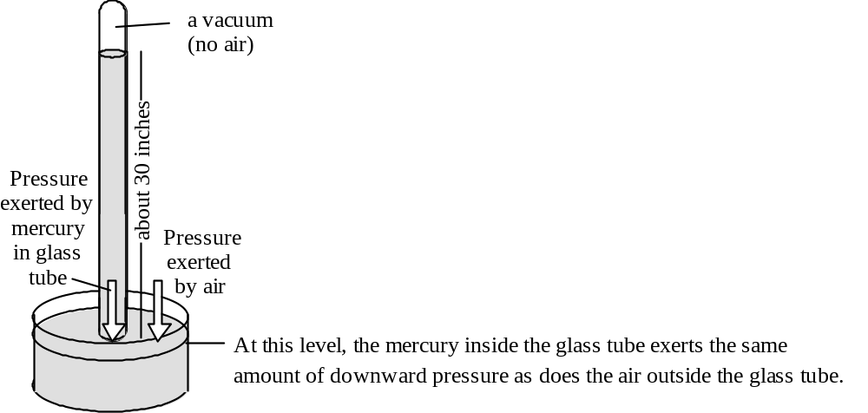
Mr. Torricelli also noticed that, over a period of several days, the level of the mercury in the glass tube would fluctuate gradually, never going much higher than 31 inches or much lower than 29 inches. These fluctuations in the level of mercury in the glass tube were caused by fluctuations in the air pressure. Let's see how this works. What would happen if the air pressure increased? The air would exert more downward pressure on the mercury in the dish, pushing the mercury down a little, forcing mercury to rise up into the glass tube. When would the mercury stop rising? When the level was high enough that the pressure exerted by the mercury in the glass tube was once again equal to the pressure exerted by the air. Question: What would happen if the air pressure decreased? Why?
You may be wondering why Torricelli used such a rare and toxic substance as mercury. He used mercury because it is the densest liquid known (mercury has a density of 13.3 g/cm3--water only has a density of 1 g/cm3) and, thus, we don't need a very high column of mercury to exert the same amount of pressure as the air does. If we used water, we would need a column 10 meters (32.8 feet) tall to exert the same amount of pressure as the air does at sea level.

How a Drinking Straw Works
Have you ever wondered why a drinking straw works? It works on the same principle as a mercury barometer. When a drinking straw rests in a glass of soda, the level of the soda in the drinking straw is the same as the level of the soda in the glass because the air pressure is the same inside the straw as in the air around it. When you suck on the straw, however, you remove the air from the top of the straw. Since there is no longer air pressing down on the soda inside the straw, the air pressure on the soda in the glass forces the soda up the straw and into your mouth. Question: Does it matter how long the straw is? Could you drink soda from a 10 foot long straw? A 50 foot long straw? What is the longest straw that would work? Why? Does it matter what your elevation is? If not, why not? If so, why and how?
Hint: If a column of water 10 meters tall exerts the same amount of pressure as the air does (at sea level), could we ever get water more than 10 meters up into a straw just by withdrawing air from the top of the straw?

Air Pressure and the Movement of Air
Basic Concepts
Air pressure is not the same everywhere. It varies from place to place and that variation is gradual, not abrupt. For example, if the air pressure is 1007 mb in one place and 990 mb in another, the air pressure will not suddenly jump from 990 mb to 1007 mb in one spot. Rather, there will be a more-or-less gradual change in pressure, called a pressure gradient, between the two places (See the diagram below). The air pressure gradient is analogous to the slope of the ground between a hilltop and a valley bottom.

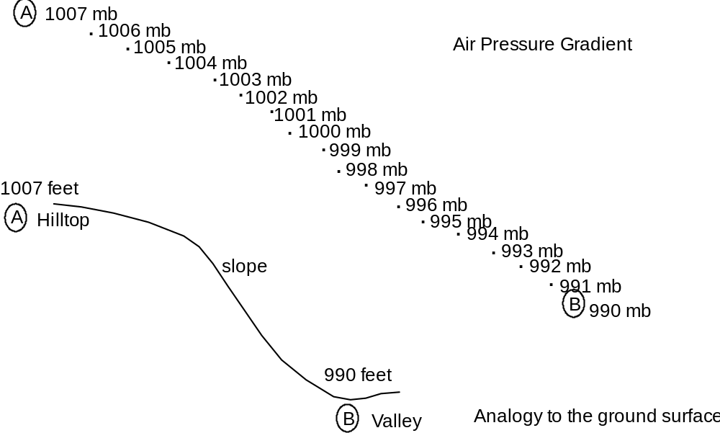
Whenever there is a pressure gradient between two locations, air tries to move in such a way as to equalize the pressure. For example, the air inside a fully inflated bicycle tire has a pressure of 65–100 pounds per square inch (depending on the type of tire). At sea level, the air surrounding this tire has a pressure of only about 14.2 pounds per square inch. Thus there is a significant difference in air pressure inside and outside of the tire. This difference can be maintained only as long as the tire has no leaks. But if you pop a tire on your bicycle, allowing air to flow in and out of the tire, air will rush out of the tire until the air pressure inside the tire is the same as the air pressure outside the tire. Similarly, when you blow up a balloon and pinch the opening closed, the air pressure inside of the balloon is higher than the air pressure outside of the balloon. As soon as you let go of the opening, air rushes out of the balloon until the pressure inside the balloon is the same as the pressure outside. Similarly, a vacuum-packed can, such as a can of coffee grounds or tennis balls, has almost no air inside of it and therefore the air pressure inside the can is extremely low. As soon as you open the can, air suddenly rushes inside the can until the air pressure inside the can is the same as the air pressure outside the can.
In summary, air tends to flow from a region of high pressure to a region of low pressure. This is an incredibly important principle in meteorology. It is THE explanation for why the wind blows--much more on this later. Whenever there is a pressure difference between one location and another, we call the force that tends to move the air from the region of high pressure to the region of low pressure the pressure gradient force. The steeper the pressure gradient (i.e. the more rapidly air pressure changes with distance), the stronger the pressure gradient force and the faster the air will flow. This is analogous to the slope of a ski hill. The steeper the slope of the hill, the faster your snow board or skis will carry you down it.

Vertical Pressure Differences and Movement of Air
Earlier in this reading, we emphasized that air pressure decreases significantly with altitude. Thus, there must be a pressure gradient force pushing the air upward (i.e. from high pressure near the ground toward low pressure aloft). One might ask, then, why air from low altitudes doesn't rush up to high altitudes in order to equalize the pressure. The answer is that gravity pulls the air down. In fact, at any given altitude, there is usually a balance between the force of gravity and the pressure gradient force. Where there is a lack of balance between these forces, air will either rise or sink. For example, if the air is denser than normal near the surface, you will climb up through the air molecules faster than usual (i.e. the number of molecules above you will rapidly decrease as you rise). As a result, the pressure gradient will be greater than normal and the pressure gradient force will be stronger than normal. As a result, the vertical pressure gradient force will be greater than the force of gravity, causing the air to rise. Alternatively, if the air is denser than normal aloft, when you are near the surface or at moderate altitudes, your air pressure will change gradually as you rise because the high concentration of air molecules remains above you. As a result, the vertical pressure gradient force will be weaker than normal. As a result, the vertical pressure gradient force will be weaker than the force of gravity, causing the air to sink.
You may be wondering why anyone would care whether the air is rising or sinking. Meteorologists actually care a great deal because rising air is, by far, the most important cause of cloud formation. Conversely, sinking air is the most important cause of clear skies. In future readings, we will explore, in detail, why and how rising air causes cloudy skies and sinking air causes clear skies.

Horizontal Pressure Differences and Movement of Air
The most dramatic pressure differences we observe are those between low and high altitudes; i.e. vertical pressure differences. However, there are also pressure differences between different locations at the same altitude--horizontal pressure differences (see Figure 18.5 on p. 517 for an example of a map of horizontal pressure differences). Even though horizontal pressure differences are usually not very large, they are extremely important because they cause all wind (wind is, by definition, a horizontal flow of air). Wind is, in essence, air trying to flow from a location with higher air pressure to a location with lower air pressure.

How and Why do Clouds Form?
The answer to this question is much like a puzzle. You need to understand lots of individual pieces before you can put them all together to see the whole picture. Here are the various puzzle pieces.

Puzzle Piece #1: What are clouds?

Clouds are “visible aggregates of minute droplets of water or of tiny crystals of ice” (p. 493 of the textbook). You may have noticed that the substances that make up clouds are denser than air. You may therefore be wondering why clouds stay up in the air--why don't they sink to the ground? This is because air is constantly moving, at least a little, and even very slight movement is enough to keep the tiny cloud “particles” suspended in the air. This process is similar to the process that keeps tiny detrital sedimentary particles (such as clay) suspended in water (which has a lower density than clay does): as long as there is any water movement, the water continues to “push up” the sedimentary particles and they remain suspended.

Puzzle Piece #2: How do clouds form?

Clouds form by condensation or freezing of water vapor. Both of these processes are changes of state. For more detailed information about changes of state, see p. 478–480 in the textbook.

Puzzle Piece #3: Evaporation and condensation are affected by humidity. What is humidity and what causes it to change?

For a detailed explanation of the concept of humidity, see p. 480–485 in the textbook.

Puzzle Piece #4: What causes warm moist air to cool to its dew point temperature, thereby causing condensation of water vapor?

Clouds form whenever water condenses in mid-air. This happens whenever the air becomes saturated with water vapor (i.e. relative humidity reaches 100%). As we just learned from pages 436–441 of the textbook, there are two ways to increase the relative humidity of the air. In nature, the most common cause for condensation is a drop in the temperature of the air to a temperature below its dew point. But what could cause such a temperature drop?
Imagine a large “parcel” of air inside a weightless infinitely stretchable balloon that allows the parcel of air to expand or compress as it wishes but prevents the air inside from mixing with the surrounding air and prevents the air inside the balloon from giving heat energy to or receiving heat energy from the surrounding air. When this parcel of air is compressed so that its volume decreases, the temperature of the air in that parcel increases. Why? Because, in order to compress air, work must be done on it--as you experience whenever you pump up a bicycle tire. Have you ever noticed how warm that tire pump becomes? As you work to pump up the tire, you are putting energy into the air inside the tire pump. That energy is stored in the air inside the pump as internal heat energy, causing the temperature of the air to rise. In summary, whenever air is compressed without exchanging heat with the surrounding air, its temperature increases. The opposite happens when you allow air to expand--it cools! If it cools to the dew-point of the air, condensation occurs.

Puzzle Piece #5: What could cause air to expand?

Now all we have to do is figure out what could cause air to expand. Recall that air pressure decreases as altitude increases. If our air parcel were to rise, the pressure on it would decrease. This decrease in pressure would cause the volume of the air parcel to increase--the air in the parcel would expand. If the air parcel keeps rising (and therefore expanding), eventually the temperature inside the air parcel will be below the dew point of that air and some of the water vapor in the air will condense--form a cloud.
So, to form a cloud, all we have to do is to get air to rise high enough that it will expand enough that its temperature will decrease enough to cause the air to become saturated with water vapor. Which leads us to our next puzzle.

Puzzle Piece #6: What causes air to rise?

There are four types of conditions that can cause air to rise. These conditions are described in the textbook in the section entitled “Processes that Lift Air” (p. 486–489).
The fourth condition described by the textbook, “convective lifting,” is our old friend convection: air near the ground often heats up and expands, decreasing its density and increasing its buoyancy. Convective lifting is the major cause of summer thunderstorms.
Yet, if you stop and think about it, convection really shouldn’t work. Why? Because air always cools as it rises. Here’s how it works: air is heated near the ground, causing it to expand. This expanded air is less dense and more buoyant than the air around it, so it rises. As it rises, the pressure on it decreases and so it expands some more. Since this air has now left its heat source—the ground—it must cool as it expands. You would think that this cooling would immediately stop the air from rising. And, sometimes, it does. However, on a warm humid day, the air can continue to rise until it forms very tall clouds, commonly called “thunderheads.” (See the cumulonimbus cloud on p. 497 of the textbook.). How can the air continue to rise even as it cools?

Puzzle Piece #7: What causes air to sometimes continue to rise, even as it cools?

Recall that, in the troposphere, the temperature of the air generally decreases with altitude. Thus, as an air parcel rises, it enters surrounding air with a lower air temperature. Therefore, even if the air parcel cools as it rises, it may still be warmer than the surrounding air. This will be true if the air parcel starts out warm enough and if the air cools rapidly enough with altitude. For an example of this phenomenon, see the lab on clouds in this course packet.

Note: All of the reading for this homework assignment is from within the course packet. I am currently writing an Earth Science textbook. In order to try out some passages on a real audience, I have inserted them into the course packet. Please let me know what you think of them. Thank you!

Previous knowledge on which this reading builds: You know that the intensity of incoming solar energy affects the temperature of the air. For example, it is warmer in summer than in winter because the intensity of the solar energy reaching a given area is greater in summer than it is in winter. Similarly, on any given day it is warmer in Chico than in Anchorage because the intensity of the solar energy reaching the Chico area is always greater than the intensity of the solar energy reaching the Anchorage area.

The question now is “How does solar energy warm Earth's atmosphere?” You may suppose that the answer to this question is simple: the atmosphere absorbs the energy from the sun and this absorbed energy warms the atmosphere. However, it turns out that the answer is much more complex. Once we understand this complex answer, we can also understand why the hottest time of the day is some time after noon and why the hottest part of the year is after June 21st. Keep this central question in mind as you do the reading for this homework assignment.

Questions (Based on Introduction to the Atmosphere in this course packet and some diagrams in the textbook)

Composition of the Atmosphere

A. What is the composition of “clean dry air” (i.e. air with all of the water vapor, dust and smoke removed)?

B. Carbon dioxide (CO2)
1. Carbon dioxide makes up % of the air.

2. Carbon dioxide makes up a tiny proportion of the atmosphere. Why is it so important?

a.

b.
C. Water Vapor
1. How is water vapor different from regular liquid water?

2. Water vapor makes up % of the air.
3. The air in the Sacramento Valley has a higher / lower (circle the correct answer) water vapor content than does the air on top of Mt. Lassen.
4. Why is water vapor important?

a.

b.

Temperature
What is Temperature?
A. What is temperature really a measure of?

B. Internal Heat Energy
1. In which of the following do the individual molecules have the most kinetic energy: a tub full of warm water (100°F) or a small pan of boiling hot water (212°F)? Explain.

2. Which contains more total heat energy, a tub full of warm water (100°F) or a small pan of boiling hot water (212°F)? Explain.

Additional Information About Temperature
A. How is the movement of a whole mass of air (e.g. wind) different from the molecular motions that give air its temperature?

How do we Measure Temperature?
A. How Our Bodies Sense Temperature
1. How does high humidity make warm air feel warmer than it is?

2. If the air temperature is 95°F in the shade, what is the air temperature in the sun? Explain.

B. How Thermometers Measure Temperature

1. Describe how a liquid-in-glass thermometer works.

2. Why should we always put a thermometer in the shade?

Layers of the Atmosphere
In addition to the text in this course packet, see also Figure 16.8 on p. 455 of the textbook.
A. Draw a diagram showing the ground, the troposphere, the tropopause and the stratosphere. Be sure to show the vertical thickness of each layer and the altitude of each boundary.

B. What physical characteristic defines the tropopause, the boundary between the troposphere and the stratosphere?

C. Why does the troposphere turn over regularly while the stratosphere remains stratified?

The Greenhouse Effect

The Storage of the Heat Energy in the Atmosphere
A. Earth is constantly radiating out just as much energy as is coming in. So why does the atmosphere have any internal heat energy at all?

Electromagnetic Radiation
In addition to the text in this course packet, see also Figure 16.18 on p. 462 of the textbook
A. The electromagnetic spectrum
1. What is electromagnetic radiation?

2. What key characteristic distinguishes one type of electromagnetic radiation from another?

B. Emission of Electromagnetic Radiation
1. The type of electromagnetic radiation emitted by an object changes with temperature.
Specifically, the higher the temperature of an object, the more / less total
electromagnetic energy it emits and the shorter / longer the average wavelength of
the radiation that it emits (circle the correct answers).
2. What is the primary type of electromagnetic radiation emitted by the sun?

3. What is the primary type of electromagnetic radiation emitted by Earth?

C. Temperature Changes Resulting from Absorption and Emission of Electromagnetic Radiation
1. When an object emits electromagnetic energy, its temperature increases / decreases .
2. When an object absorbs electromagnetic energy, its temperature increases / decreases .

D. Selective Absorption and Emission of Electromagnetic Radiation
1. Why do you get warm when you sit in the sun on a cool day while the air itself stays cool?

2. Which atmospheric gases can absorb visible light? ___________________________
3. Which atmospheric gases can absorb infrared radiation?
How the Greenhouse Effect Works
In addition to the text in this course packet, see also Figures 16.20 (p. 463) and Figure 16.23 (p. 466) of the textbook.
A. How the Greenhouse Effect Works
1. Step 1 (See this course packet and Figure16.20 on p. 463 of the textbook):
Of all of the solar energy that reaches Earth…

% is reflected and scattered back into space

% is absorbed by the atmosphere

% makes it through the atmosphere and is absorbed by Earth’s land-sea surface
100%
2. Step 2 (See this course packet and the middle frame of Fig. 16.23 of the textbook)
The energy that is absorbed by Earth’s land-sea surface acts to heat the land and sea. What eventually happens to that energy?

3. Step 3 (See this course packett and the right-hand frame of Fig. 16.23 of the textbook)
What happens to the energy that is emitted by the land, sea and other objects on Earth’s surface?

4. Thought Question: What do you suppose would happen if the levels of greenhouse gases in the atmosphere would increase and a higher proportion of the infrared radiation emitted by the ground were absorbed by greenhouse gases?

B. Implications of the Uneven Distribution of Greenhouse Gases
1. Why does air temperature generally decrease with altitude (in the troposphere, anyway)?

2. Is the troposphere heated from above or below?
Introduction to the Atmosphere - In this course packet

Air Pressure
Description of Air Pressure
A. Explain why the upside-down glass trick works.

B. Will it still work with a REALLY tall glass (taller than 10 meters)? Explain.

C. What would happen if the index card on the bottom of the glass sprung a leak? Why?

D. The Relationship Between Air Pressure and Air Density
1. When the air pressure increases (even if the temperature of the air doesn't change),
the density of the air increases / decreases .
2. Gases are perfectly compressible. What does this statement mean?

E. Variations in Air Pressure With Altitude
1. Why do our ears pop when we drive up into the mountains or down into a valley?

2. Why do we get out of breath when we hike in the high mountains?

What Causes Air Pressure?
A. What causes the air to exert pressure?

B. Why does air pressure decrease with altitude?

Measuring Air Pressure
A. How a Barometer Works
1. Add to this diagram of the barometer made by Evangelista Torricelli and explain how the barometer works
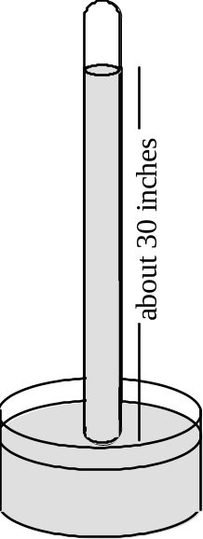
2. Why did Torricelli use mercury and not a more common, less toxic substance?

B. How a Drinking Straw Works: What is the longest drinking straw that would work? Why?
Hint: This question is related to the glass-of-water trick.

Air Pressure and the Movement of Air
A. Basic Concepts
1. What is a pressure gradient?

2. Wherever there is a pressure gradient, air tries to move…

from high / low pressure to high / low pressure (circle the correct answers).

3. The steeper the pressure gradient, the stronger / weaker the pressure gradient force and the faster / slower the air will flow and the harder / softer the wind will blow. (circle the correct answers).
B. Vertical Pressure Differences and Movement of Air
1. Why doesn't air at low altitudes rush up to high altitudes?

2. If the air is denser than normal at the surface (but normal aloft), air will rise / sink
because the pressure gradient force is stronger / weaker than normal so the pressure
gradient force overcomes / is overcome by gravity. (Circle the correct answers)
3. If the air is denser than normal aloft (but normal at the surface), air will rise / sink
because the pressure gradient force is stronger / weaker than normal so the pressure
gradient force overcomes / is overcome by gravity. (Circle the correct answers.)

4. If the air is less dense than normal at the surface (but normal aloft), air will rise / sink
because the pressure gradient force is stronger / weaker than normal so the pressure
gradient force overcomes / is overcome by gravity. (Circle the correct answers.)

5. If the air is less dense than normal aloft (but normal at the surface), air will rise / sink
because the pressure gradient force is stronger / weaker than normal so the pressure
gradient force overcomes / is overcome by gravity. (Circle the correct answers.)

C. Horizontal Pressure Differences and Movement of Air: What kind of air movement is caused by horizontal pressure differences?

Chapter 18 of the textbook - Air Pressure and Wind

Factors Affecting Wind (p. 516–520)
In Homework Assignment #10, you found out that wind is caused by horizontal (sideways) differences in air pressure. We now focus on how the Coriolis effect acts to modify wind direction. Remember, however, that the Coriolis effect cannot cause the wind to blow.

A. Coriolis Effect (p. 517)
1. “All free-moving objects, including the wind, are deflected to the…
right / left of their path of motion in the Northern Hemisphere and to the
right / left [of their path of motion] in the Southern Hemisphere.”
2. The Theoretical Rocket Launched from the North Pole (Figure 18.6 on p. 518):
Description of What the Diagram Shows: A rocket is launched from the North Pole straight toward a target on the Equator. The rocket takes one hour to reach the equator but it does not hit the target. Instead, it hits a point 15° west of the target.
a. If you were an astronaut sitting on the moon (preferably during a new moon so that the Earth, as seen from the moon, was “full”--think about it!), and you were tracking this flying rocket, you would see that the rocket was really traveling…
in a straight line / along a curved path .
b. In your own words, explain why the rocket hits a point 15° west of the target.

Highs and Lows (p. 520–523)
A. Definitions
1. At a low pressure center (cyclone), pressure decreases / increases from the outside toward the center.
2. At a high pressure center (anticyclone), pressure decreases / increases from the outside toward the center.

B. Cyclonic and Anticyclonic Winds (In addition to reading the text, study Fig. 18.11 on p. 521.)
1. Cyclonic Winds
a. In the northern hemisphere, winds blow inward / outward and
clockwise / counterclockwise around a low pressure center.
b. The (map view) diagram below shows the wind directions in the vicinity of a low-pressure center, if there were no Coriolis effect. Add arrows to this diagram, showing which way the winds actually do blow (due to the Coriolis effect). Check the right half of Figure 18.11 on p. 521 to see if your diagram matches reality.
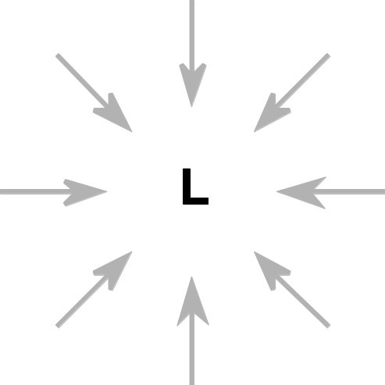
2. Anticyclonic Winds
a. In the northern hemisphere, winds blow inward / outward and
clockwise / counterclockwise around a high pressure center.
b. The (map view) diagram below shows the wind directions in the vicinity of a high-pressure center, if there were no Coriolis effect. Add arrows to this diagram, showing which way the winds actually do blow (due to the Coriolis effect). Check the left half of Figure 18.11 on p. 521 to see if your diagram matches reality.
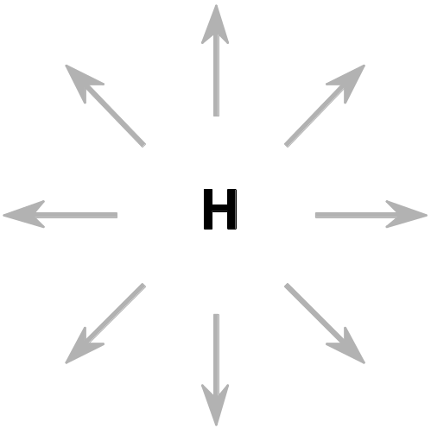
C. Weather Generalizations About Highs and Lows
1. Rising vs. Sinking Air
a. Rising air is associated with clouds and precipitation / clear skies .
b. Sinking air is associated with clouds and precipitation / clear skies .

2. Air circulation around a surface low pressure system
a. For a low pressure center to continue to exist at the earth's surface, the air located high above the ground must be flowing in such a way as to keep the surface air pressure--at the low pressure center--low, even though air at Earth’s surface is flowing in from all sides. The right side of Figure 18.13 on p. 522 shows one type of air circulation pattern that could cause the low pressure center to keep its low pressure.
Draw arrows on the diagram below to show this air circulation pattern.
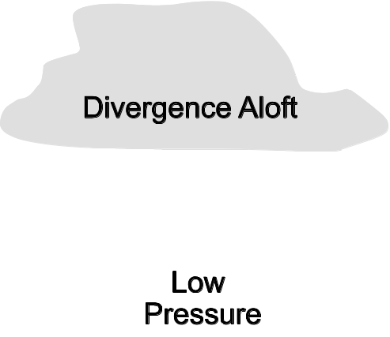
b. Air tends to sink / rise at surface low pressure centers. Thus surface low pressure centers are associated with clouds and precipitation / clear skies

3. Air circulation around a surface high pressure system
a. For a high pressure center to continue to exist at the earth's surface, the air located high above the ground must be flowing in such a way as to keep the surface air pressure--at the high pressure center--high, even though air at Earth’s surface is rushing away in all directions. The left side of Figure 18.13 on p. 522 shows this movement of air.
Draw arrows on the diagram below to show this air circulation pattern.
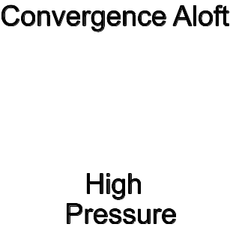
b. Air tends to sink / rise at surface high pressure centers. Thus surface high pressure centers are associated with clouds and precipitation / clear skies .
4. In the mid-latitudes of the Northern Hemisphere, high- and low-pressure centers tend to migrate…
from the west to the east / from the east to the west.

5. In addition to measuring pressure, temperature and wind conditions at the earth's surface, weather forecasters must also measure the patterns of air flow high above the ground. Why?

Chapter 18 of the textbook - Air Pressure and Wind

General Circulation of the Atmosphere (p. 523–526)
A. The underlying cause of wind on Earth is… .
1. In tropical regions, the ground and the overlying atmosphere receive more / less radiant energy from the sun than they radiate back into space.
2. In polar regions, the ground and the overlying atmosphere receive more / less radiant energy from the sun than they radiate back into space.
3. How do atmospheric winds act to transfer energy from the tropics to the poles?

B. Global air circulation on “a hypothetical non-rotating planet with a smooth surface of either all land or all water” (In addition to reading the text, see Figure 18.15 on p. 524.)
1. Describe and draw the circulation of air on such a hypothetical planet:

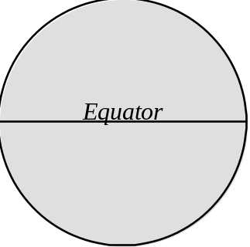
2. Why would air rise at the equator?
Hint: it has to do with density and buoyancy.

3. Why would air sink at the poles?
Hint: it has to do with density and buoyancy.

C. The Trade Winds
For Your Information: The real Earth rotates. As a result, we do not have just two convection cells--1) from the equator to the north pole and 2) from the equator to the south pole. Instead, we have a much more complex pattern of convection. The air circulation at latitudes higher than 30° is especially complicated--that is why our weather is so “interesting.” However, there does appear to be one coherent rather simple convection cell in each hemisphere, extending from the equator to about 30° latitude. These convection cells, called the “Hadley Cells,” are shown in Figure 18.16 on p. 524. The Hadley Cells nicely explain the trade winds.
Note: To figure out the answers to the questions below, think about your answers to previous questions in this homework assignment. You will also want to use what you learned in the lab activity on global air circulation.
1. Air rises at the equator because it is warm, has a low-density, and is therefore buoyant.
a. Air pressure aloft at the equator is therefore higher / lower than it is at the poles. (Circle the correct answer.)
b. Surface air pressure at the equator is therefore higher / lower than it is at the poles. (Circle the correct answer.)
2. The air that rose near the equator, now located aloft, tries to blow toward the poles.
a. Why does the air aloft try to blow toward the poles?

This air aloft, which is trying to blow toward the poles, is deflected a bit by the Coriolis effect but it does generally make its way poleward. As it does so, this air radiates energy and cools. Eventually, at about 30° latitude, much of the air cools and compresses enough to lose its buoyancy. As a result, it sinks.
b. Surface air pressure at 30° latitude is therefore higher / lower than it is at the equator. (Circle the correct answer.)
c. As a result, the surface winds (the Trade Winds) try to blow (Circle the correct answer.)
from the equator toward 30° latitude / from 30° latitude toward the equator
d. In the northern hemisphere, the Coriolis force causes these winds to be deflected toward the right / left (Circle the correct answer.).
e. Thus the surface winds (the Trade Winds) between 0° and 30° N. latitude blow from the . (See Figure 18.16 on p. 524.)
f. In the southern hemisphere, the Coriolis force causes the winds to be deflected toward the right / left (Circle the correct answer.).
g. Thus the surface winds (the Trade Winds) between 0° and 30° S. latitude blow from2 the . (See Figure 18.16 on p. 524.)
Local Winds (p. 526–529)
Sea and Land Breezes (In addition to reading the text, study Figure 18.18 on p. 527.)
Additional Information Not Given by the Book:
Whenever any type of matter (rock, soil, sea water, atmospheric gas) absorbs radiant energy, its temperature increases. However, two different kinds of matter can absorb the same amount of radiant energy but increase their temperature by different amounts. For example, it takes more energy to cause a 1° temperature rise in a given amount of water than it takes to cause a 1° temperature rise in the same amount of rock. As a result, if a large body of water (such as the Pacific Ocean) and a large chunk of rock (such as a California beach) both soak up the same amount of solar energy on a sunny day, the land will become warmer than the water does.
Similarly, whenever any type of matter (rock, soil, sea water, atmospheric gas) emits radiant energy, its temperature decreases. However, two different kinds of matter can emit the same amount of radiant energy but decrease their temperature by different amounts. For example, when a given amount of water emits a certain amount of radiant (infrared) energy, it experiences a less dramatic drop in temperature than when the same amount of rock emits the same amount of radiant energy. As a result, if a large body of water (such as the Pacific Ocean) and a large chunk of rock (such as a California beach) both emit the same amount of infrared radiation on a clear dark night, the land will become cooler than the water does.
1. During daylight hours, especially in the afternoon, a breeze typically blows from the sea toward the land. This is called a sea breeze. Explain why this breeze occurs, using your understanding of convection (including how temperature changes cause changes in volume, density and buoyancy).

2. During the night, a breeze typically blows from the land toward the sea. This is called a land breeze. Explain why this breeze occurs, using your understanding of convection (including how temperature changes cause changes in volume, density and buoyancy). Draw a diagram to illustrate your answer.

Chapter 19 – Weather Patterns and Severe Storms

Air Masses (p. 540–542)
A. What is an air mass?

B. Source Regions
1. What is meant by the source region of an air mass?

2. Describe the temperature (Cold vs. Warm) and moisture (humid vs. dry) characteristics of each of the following types of air masses:

a. Maritime Tropical:

b. Maritime Polar:

c. Continental Tropical:

d. Continental Arctic:
Fronts (p. 543–546)
A. What are fronts?

B. How wide are fronts?
C. When two air masses clash, which air mass is forced aloft?
D. Warm Fronts vs. Cold Fronts: Complete the table below

 | Warm Front | Cold Front
Definition
Draw the symbol used on weather maps
Steepness of the front
Speed of advance
(slow vs. fast)
Intensity of precipitation (light vs. heavy)
Duration of precipitation (short vs. long)
Temperature change
(sharp vs. gradual)

Chapter 17 – Moisture, Clouds, and Precipitation
Note: The remainder of this homework assignment will guide you to skip back and forth within Chapter 17 and to read the Supplemental Reading on Clouds in this course packet. To avoid confusion, pay careful attention to the page numbers listed for each section. I have arranged the readings in an order that seems most effective for constructing an understanding of how and why clouds form. The format is one of a puzzle (how and why do clouds form?). If my suggested order doesn't work for you, feel free to read the various passages in any order you like, including the order in which they appear in the book.

Puzzle Piece #1: What are clouds?

Read the 1st section of the Supplemental Reading on Clouds (p. 283 of this course packet)
A. What are clouds made of?

Puzzle Piece #2: How do clouds form?

Water’s Changes of State (p. 478–480 of the textbook)--Read only enough of this section to get the information you need to answer the questions below.
A. What is the difference between “water vapor” and “water?” (See Figure 17.2 on p. 479.)

B. Liquid / Gas Change of State (p. 478–479)
1. What is evaporation?
2. What is condensation?
C. The roles played by these changes of state
1. Which of these changes of state causes water to go into the air?
2. Which of these changes of state results in the formation of clouds?

Puzzle Piece #3: Evaporation and condensation are affected by humidity. What is humidity and what causes it to change?

Humidity: Water Vapor in the Atmosphere (p. 480–485 of the textbook)
A. Basic Concepts
1. What is the definition of the term humidity?

2. Describe what it means to say that air is saturated with water vapor?

3. Water vapor capacity
a. What is meant by the water vapor capacity of air?

b. The higher the air temperature the greater / smaller the water vapor capacity of that air (Circle the correct answer.).
Hint: Examine Table 17.1 on p. 481. It shows how many grams of water vapor a kilogram (1000 grams) of air can hold at various air temperatures.

4. Relative Humidity
a. What is meant by relative humidity?

b. On Figure 17.4A (p. 482), it states that the relative humidity of the air in the flask is 25%. Explain how the authors of the book arrived at this answer.

c. When air is saturated with water vapor, what is its relative humidity?
B. Two Ways to Increase the Relative Humidity of the Air
1. Describe how method #1 (shown in Figure 17.4 on p. 482) causes relative humidity to increase.

2. Describe how method #2 (shown in Figure 17.5 on p. 482) causes relative humidity to increase.

C. Dew Point Temperature (p. 483)
1. What is meant by dew point temperature?

2. On Figure 17.5 (p. 482), what is the dew point temperature for the air in Flask A (Initial Condition)? Explain the reasoning behind your answer.

3. If Flask A in Figure 17.5 (p. 482) had 10 grams of water vapor in it, instead of only 7, would its dew point be the same as it was when the flask had 7 grams of water vapor in it? If not, would the dew point be higher or lower? Explain the reasoning behind your answer.

4. What happens when air is cooled to a temperature below its dew point temperature?

Puzzle Piece #4: What causes warm moist air to cool to its dew point temperature, thereby causing condensation of water vapor? (p. 284 in this course packet)

In your own words, write your answer to this question here:

Puzzle Piece #5: What could cause air to expand? (p. 285 of this course packet)

In your own words, write your answer to this question here:

Puzzle Piece #6: What causes air to rise? (See p 285 of this course packet and pages 486–489 of the textbook.)

List and explain the four “processes that lift air”

a.

b.

c.

d.

Puzzle Piece #7: What causes air to sometimes continue to rise, even as it cools? (p. 286 of this course packet)

In your own words, write your answer to this question here:

Objectives
When you have completed this lab you should be able to:
1. Describe the circulation of the troposphere (the bottom layer of the atmosphere) and stratosphere (the layer above the troposphere) on a clear sunny day.
2. Explain WHY the air circulates (or doesn’t circulate) in these two layers.
3. Explain what air pressure is and describe how strong it is.
4. Describe one way to measure air pressure.
5. Explain what makes the wind blow.

Activity #1: Modeling Air Movements Caused by Heating of the Atmosphere
Materials: large beaker
two pieces of black felt, one small and circular, one large and square
food coloring
eye dropper
high-wattage (250 Watt) light on a stand
Activity
1. Fill the beaker about 3/4 full with water; this water represents the bottom two layers of the atmosphere, the troposphere and stratosphere.
2. Dampen the circular piece of black felt and press it against the bottom of the beaker. Look down into the beaker and notice the black spots and some bright spots. Continue to press the felt against the beaker, trying to maximize the area covered by black spots. The black felt represents the ground.
3. Set the beaker (and the circular piece of cloth underneath it) on the piece of square cloth. Let it rest for a minute to settle down.
4. Carefully place a dropper full of food coloring in the bottom of the beaker, disturbing the water as little as possible. The food coloring should form a dark pool at the bottom of the beaker; there should be (almost) no food coloring in the rest of the water. Suggested procedure:
a. Squeeze the bulb on the end of the eye dropper.
b. Place the eye dropper in the vial of food coloring and let go of the bulb; the eye dropper will fill with food coloring.
c. Very gently and slowly (so as not to disturb the water) lower the eye dropper to the bottom of the beaker. Gradually squeeze the bulb to release the food coloring.
d. SLOWLY release the pressure on the bulb (some water will go into the eye dropper; that's okay).
e. Very slowly lift the eye dropper out of the water.
5. Place the light bulb directly above the beaker so that it will shine straight down on the water in the beaker (See diagram below). This light represents sunlight.
4. Place a blank white piece of paper behind the beaker (making it easier to see inside the beaker). Plug in the light and watch for any motion of the colored water on the bottom of the beaker.

Questions
1. Describe any water motion you see. Complete the diagram below, showing this motion.
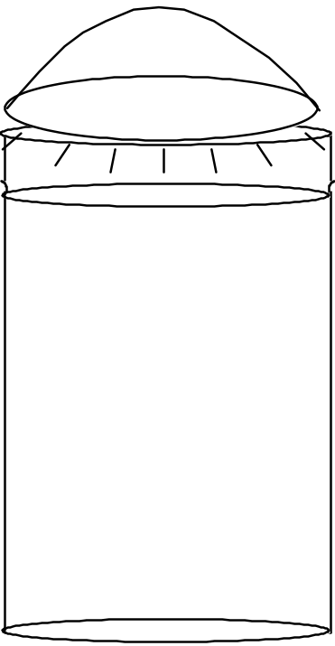
2. On the adjacent diagram, draw a line showing the boundary between the troposphere and the stratosphere.

3. Which of these two layers—if any—undergoes convection? Why?

4. Which of these layers—if any—does NOT undergo convection? Why not?

5. Using concepts you learned earlier this semester, explain why this motion occurs. As appropriate, add to the diagram above to illustrate your answer.

6. If your explanation for #2 above is correct, where should the water be warmer, at the very bottom of the beaker or near the middle of the beaker? Explain the reasoning behind your answer.

7. Applying your observations of this model to the real atmosphere, the troposphere generally
undergoes convection / does not undergo convection because it is heated from
above / below (Circle the correct answers)
Lab Activity #2: Air Pressure
Materials: drinking glass
small index card (slightly larger than the rim of the plastic cup)
Activity: Fill the drinking glass completely with water. Cover the glass with the index card. Hold your hand over the card and carefully, over a sink, turn the glass upside down. Gradually remove your hand.
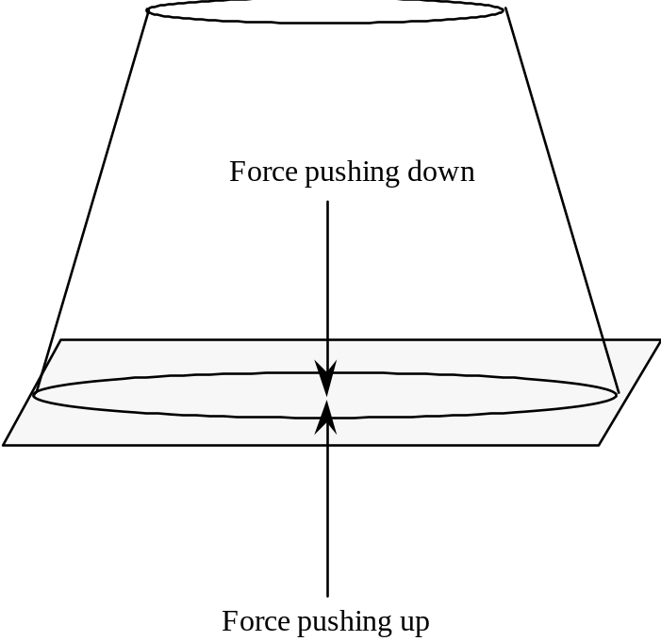
Questions:
1. There are two forces acting on the index card; one pushes up and one pushes down (see the arrows in the above diagram).
a. What is producing the force that is pushing down on the card?

b. What is producing the force that is pushing up on the card?

c. Which force is greater? How do you know?
2. If the cup were 10 ft. tall, would this “trick” still work? What about 100 ft? 1000 ft.? What would you have to know to be able to answer this question? (Hint: take a look at p. D-17 of the course packet.)

3. If you wanted the water to fall down, what could you do? Why do you think this would work?

4. Do whatever it is you think will work. Does it work?

Lab Activity #3: Changes in Air Pressure
Materials: glass tube that has been sealed at one end
beaker of red water
one bell jar with vacuum air pump
Activity:
1. (This step will be completed for you.) Completely fill the glass tube with red water. Seal the top with your finger. Turn the glass tube upside down, keeping your finger in place. Place the tube in the beaker of red water and let go of the end.
2. Place the beaker and glass tube in the bell jar. Turn on the vacuum pump and watch what happens as air is removed from the bell jar.
3. Let the air back in and watch again.
Question: Explain the behavior of the red liquid in the glass tube and the beaker as air is pumped out of the bell jar and let back in. Draw a diagram to illustrate your answer.

Lab Activity #4: Inflating and Deflating a Balloon
Materials: balloon
Activity: Blow up the balloon. Then let it deflate; put your finger near the opening to feel the air leaving the balloon.
Questions:
1. When the balloon is full of air, where is the air pressure greatest, inside the balloon or outside of it?

2. When the balloon has deflated, is there any air in it?

3. When the balloon has deflated, is there any difference in air pressure between the inside and the outside of the balloon? Explain.

4. When a balloon is deflating, why does air leave the balloon?

5. Using what you've learned from this experiment, explain what causes the wind to blow.

6. Why do you think that we sometimes have gentle breezes and sometimes have gale-force winds?

Objectives
When you have completed this lab you should be able to:
1. Explain how convection redistributes atmospheric heat energy from the equator to the poles,
2. Correctly state whether rising air is characterized by low atmospheric pressure or high atmospheric pressure and why; do the same for sinking air,
3. Explain how and why the rotation of the earth deflects the wind from its intended path (the Coriolis effect); describe which way the wind is deflected in each hemisphere (N and S).

Important Information About the Layering of the Atmosphere
Earth's atmosphere is made of four layers (Figure 16.8 on p. 455 of the textbook shows a diagram of these layers). In this class, we will only concern ourselves with two of these layers:
(1) The troposphere is the lowermost layer of the atmosphere; it is where we live and where most interesting “weather” (clouds, wind, storms, etc.) occurs.
(2) The stratosphere is immediately above the troposphere; it contains the ozone layer.
The boundary between the troposphere and the stratosphere (called the tropopause) acts like an almost impenetrable barrier to air; very little air crosses this boundary. Why? Because the bottom of the stratosphere is warmer than the top of the troposphere and you know how effectively that kind of a temperature gradient acts to prevent vertical air circulation (remember—from the lab on convection—the red-clear-and-blue water in the beaker that was heated from above?).
The near impenetrability of the boundary between the troposphere and the stratosphere is very important when it comes to understanding weather. For example, when air rises in the troposphere and hits the tropopause, it cannot push its way upward into the stratosphere. So it is forced to spread out sideways (see below). Meanwhile, the rising air leaves behind a region of extra-low-density air near the ground that pulls in air from the surrounding area. When air sinks, the opposite happens (see below). So, in many ways the troposphere behaves like a pan of water (Very little water “jumps” up into the air above; very little air penetrates down into the water.).
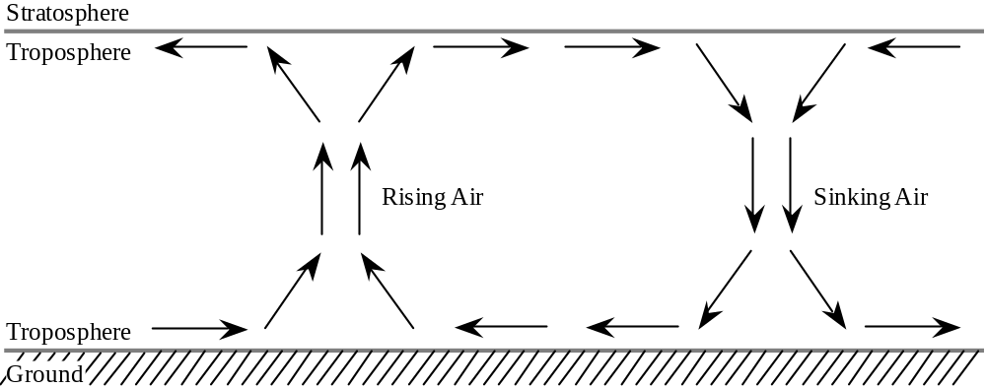
Lab Activity #1: The Atmosphere in a Cake Pan
Introduction
In this activity, we model the air movements that occur when air is cold in one place (for example, at the poles) and hot in another (for example, at the equator). We use water to represent air in the lower part of the atmosphere (i.e. the troposphere) because it's easier to observe the motion of water than it is to observe the motion of air. Keep in mind, however, what each part of the model represents:
Part of Model | Real Thing That it Represents
Bottom of cake pan | The Earth's surface
Water in the cake pan | The lowermost layer of the atmosphere (the troposphere)
Air above the cake pan | The stratosphere (the layer of the atmosphere directly above the troposphere)
Bag of ice | Cold ground near the north (or south) pole
Candles | Warm ground near the equator

Materials: large rectangular clear glass cake pan (15x10x2) gallon-size Ziploc bag
4 paper cups ice
3 votive candles red and blue food coloring
sheet of aluminum foil 2 eye droppers
small pieces of wood (2 x 4’s work well) red and blue colored pencils
box of matches
Activity
1. Fill the cake pan with water.
2. Place the four cups, upside down on the lab table, forming a rectangle that the cake pan can rest on and remain stable. Place the cake pan on the three cups.
3. Place the pieces of wood underneath one end of the cake pan, forming a line.
4. Place the aluminum foil over the wood. Let the extra cover the surrounding tabletop.
4. Place the candles on the wood and light them. Be sure the aluminum foil will prevent any wax from dripping onto the lab table. This end of the cake pan represents the warm equatorial regions of the earth.
5. Put some ice in the large Ziploc bag and place the bag of ice in the cake pan on the side opposite the candle. This end of the cake pan represents the cold polar regions of the earth. The set up should look like the diagram below.
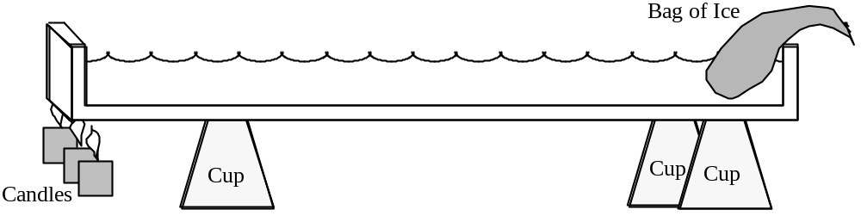
Questions
1. On the diagram on the previous page, use arrows to show any (invisible) motion of the water that you think may be occurring, due to the temperature differences across the cake pan.

2. Explain why you think the water is moving this way.

More Activity
5. After the cake pan has rested undisturbed for a few minutes, place several drops of blue food coloring in a line along the bag of ice, near where it touches the water (see diagram below).
6. Carefully place several drops of red food coloring into the water in a line along the BOTTOM of the cake pan directly above the candles (see diagram below).
7. Watch the motion of the colored water and answer the following questions.

More Questions
3. On the diagram below, use arrows and colored pencils to show the motion of the red and blue water in the cake pan.

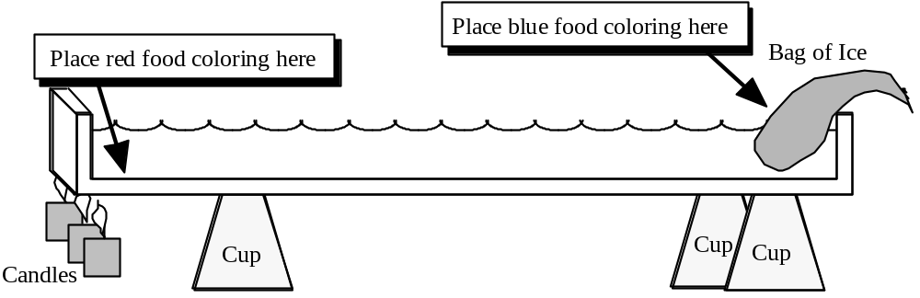
4. Did the motion you observed match your predictions (Question #1 above)?
If not, explain why the motion that you DID observe occurred.

5. What can you conclude about the density of the water near the candle as compared to the density of the water near the ice? Where is the water more dense? Why?

For questions 6–13 below, imagine that you are a tiny water-breathing person, usually walking around on the bottom of the cake pan but sometimes “flying” up in the water in an airplane.
6. As you fly around in the “air” (the water in the cake pan), near the top of the troposphere, where do you feel the highest water pressure, near the ice or near the candle? Why? Hint: Remember the recent lecture on wind.

7. On the diagram of the cake pan (previous page), place an “H” where the pressure aloft (i.e. near the top of the water) is highest and an “L” where the pressure aloft (i.e. near the top of the water) is lowest.
8. As you walk around on the “ground” (the bottom of the cake pan), where do you feel the highest water pressure, near the ice or near the candle? Why? Hint: Remember the recent lecture on wind.

9. On the diagram of the cake pan (previous page), place an “H” where the surface pressure (i.e. at the “ground”) is highest and an “L” where the surface pressure (i.e. at the “ground”) is lowest.
10. When you “fly” (in an airplane) up to the upper part of the water “atmosphere” near the center of the cake pan, which way do you feel the “wind” blow? Circle your answer.
From the pole (ice) to the equator (candle). / From the equator (candle) to the pole (ice).
11. When you stand on the “ground,” at the center of the cake pan, which way do you feel the “wind” blow ? (In other words, which way is water flowing?). Circle your answer.
From the pole (ice) to the equator (candle). / From the equator (candle) to the pole (ice).
12. When you stand on the “ground”, near the “equator,” do you feel much wind? Why or why not? (Hint: Remember that “wind” is defined as a horizontal flow of air.)

13. When you stand on the “ground”, near the “pole,” do you feel much wind? Why or why not?

Questions 14–18 below ask you to apply what you've learned from the behavior of the water in the cake pan experiment to an analysis of the behavior of the air in the upper part of the troposphere.
14. Where the air is rising, the ALOFT air pressure is higher / lower than it is at the same level wherever air is not rising.
15. Where the air is sinking, the ALOFT air pressure is higher / lower than it is at the same level wherever air is not sinking.
16. ALOFT, the polar regions are characterized by relatively high / low atmospheric pressure.
17. ALOFT, the equator is characterized by relatively high / low atmospheric pressure.
18. Winds ALOFT tend to blow from the pole to the equator / from the equator to the pole.

Questions 19–23 below ask you to apply what you've learned from the behavior of the water in the cake pan experiment to an analysis of the behavior of the air in the troposphere as experienced by people living on the Earth's surface.
19. Where the air is rising, the SURFACE air pressure is higher / lower than it is where air is not rising.
20. Where the air is sinking, the SURFACE air pressure is higher / lower than it is where air is not sinking.
21. The polar regions are characterized by relatively high / low SURFACE atmospheric pressure.
22. The equator is characterized by relatively high / low SURFACE atmospheric pressure.
23. Winds near the ground tend to blow from the pole to the equator / from the equator to the pole.
24. On the model earth below, use arrows to show the air movement (i.e. atmospheric convection) that you think would result from the contrast in air temperatures between the equator and the poles. To keep things simple, show the air movement just on the outside “edges” of the earth--where the “people” are shown. Mark each region of low pressure with an “L” and each region of high pressure with an “H.”

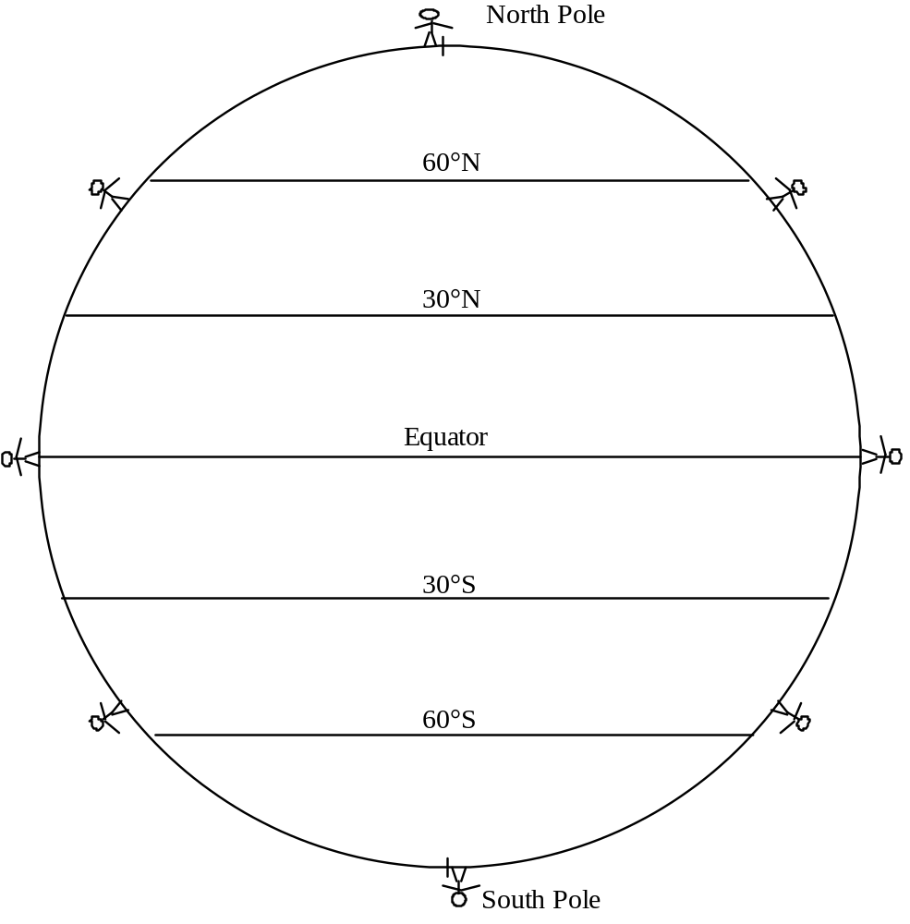

Note: This is a useful model, but it is not correct.

First, as air flows aloft from the equator toward the pole, it loses a lot of heat. By the time it gets near 30° N and 30° S latitude, a great deal of that air has cooled enough that it becomes too dense to stay aloft--thus it sinks there--most doesn't make it all the way to the pole.

Second, Earth rotates on its axis, modifying the direction that the wind blows (at least from the perspective of any one place on earth. We will now modify the model to take Earth's rotation about its axis into account.
Lab Activity #2: The Coriolis Effect on a Flat Spinning Earth
Introduction
In this activity, we begin to study the Coriolis effect, the effect that Earth's rotation has on the motion (from the viewpoint of an observer on Earth) of flying objects, including air molecules.
Materials: spinning lab stool
large piece of paper
felt-tip pen
yardstick
Activity
1. Choose a stool that spins easily. Cut out a paper circle that just fits the seat of the stool; tape the paper circle to the stool.
2. Make a mark in the center of the circle to represent the north pole; the edge of the stool represents the equator.
3. Using the yardstick as a guide, draw a path from the north pole to the equator. It should be a straight line. This is the path of an object (such as a missile) that is flying in a straight line from north to south on a NONROTATING Earth.
4. Figure out which way Earth spins, clockwise or counterclockwise, when looking down at the north pole.
5. Repeat step #3, but this time spin the stool (model Earth) in the appropriate direction at a slow constant rate while guiding the pen along the yardstick. This is the path of an object that is flying in a straight line from north to south on a ROTATING Earth.

Questions
1. On the circle below, show the two paths that you drew on the large circle of paper.
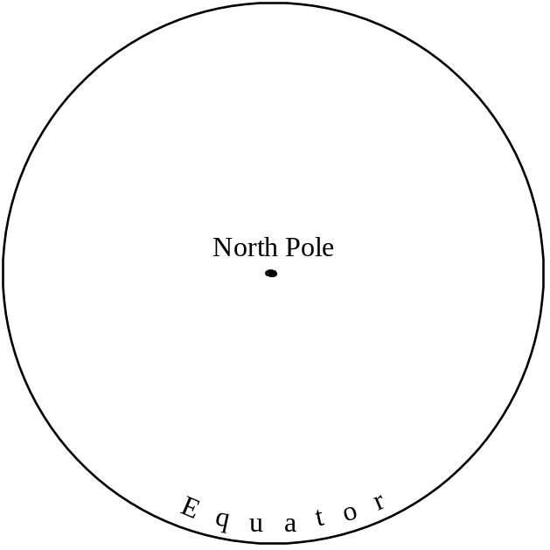
2. When you drew the line while rotating the seat of the stool, in which direction (to the right or to the left) was the pen deflected from the intended path (Imagine yourself traveling with the pen tip, looking forward.)?

3. The experiment you did was a model of the situation for the northern hemisphere. Would objects be deflected in the same direction in the southern hemisphere? Explain why or why not.

Lab Activity #3: Coriolis Effect on a Spherical Spinning Earth
Introduction
In this activity, we continue to study the Coriolis effect. This time, we make it a bit more realistic by using a spherical Earth instead of a flat earth.
Materials: “chalk board” globe (We have only two of these, so the groups will have to take turns.)
piece of chalk
Activity
1. Without spinning the globe and using the metal arch around the globe as a guide, draw a straight line from the north pole to the equator.
2. Repeat step #1, but this time spin the globe slowly and steadily in the appropriate direction.
3. Repeat steps 1 and 2 but draw your line from the south pole to the equator.
Question: Does the spherical globe display a Coriolis effect similar to the flat lab stool?

Lab Activity #4: The Coriolis Effect on Objects “Launched” from
Somewhere Other than the Poles

Introduction: We will now study how the Coriolis effect works if the object is “launched” from somewhere other than the North or South Pole. This makes things a bit more complicated and almost impossible to model physically. So, we will explore this issue by solving a couple of math “word problems.”
1. Imagine a war between Canada and the United States (fortunately, this is a highly unlikely scenario) in which the Canadians shoot a missile from Vancouver, aiming straight south toward San Francisco. Here is some important information:
• The distance between the two cities is 1300 km.
• The missile travels toward the south at a speed of 1300 km/hour.
• Because the missile was launched from Vancouver, it also travels toward the east at the same speed that Vancouver is traveling eastward.
• As the earth revolves around its axis…
Vancouver is constantly circling eastward at a speed of 1100 km/hour.
San Francisco is constantly circling eastward at a speed of 1300 km/hour.
a. Why is San Francisco circling eastward faster than Vancouver is?

b. Problem to solve: Where will the missile actually land and why?
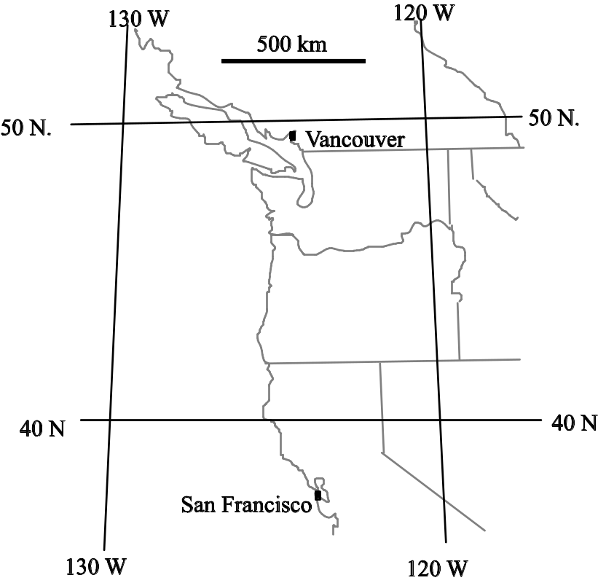
2. Even though the missile did not hit San Francisco, the United States is angry about the attempted missile attack and wants to shoot a missile from San Francisco so that it will hit Vancouver. But, like the Canadians, the Americans do not take the Coriolis effect into account. Where will their missile land and why?
Lab Activity #5: Adding the Coriolis Effect to the
Convection Model--Surface Winds
Introduction: It is now time to modify the convection model that you constructed in Activity #1 to take the Coriolis effect into account.
In this model, we will focus on the regions between 30° N and 30° S latitudes--where the trade winds blow. At higher latitudes, the wind direction isn't nearly as consistent, partly because the Coriolis effect is so strong--the higher the latitude, the stronger the Coriolis effect.
In this model, we will also focus on the direction of the surface winds, i.e. the winds near the ground. We will not worry about the winds aloft yet--we will in the next activity.
Activity: Look at your model from Activity #1 to see which way the surface winds want to blow in each hemisphere. Figure out which way the wind is deflected and show the direction of the wind, using a curved line with an arrow at the end. Draw these lines all across the globe between 0° and 30° N and between 0° and 30°S. The lines should be different in the northern and southern hemispheres.
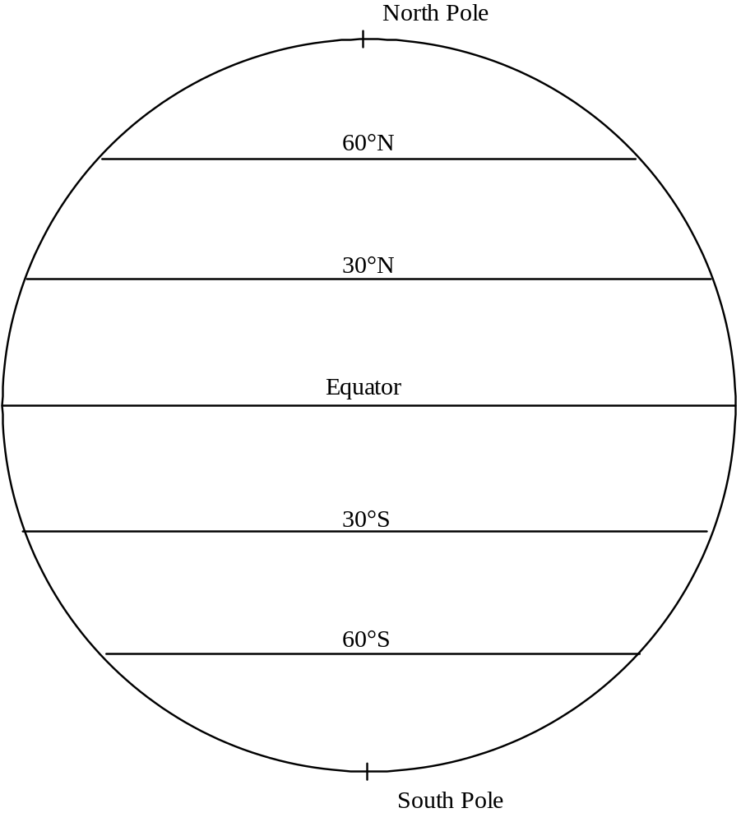
1. Are the trade winds in the northern hemisphere easterly (out of the east) or westerly (out of the west)? Why?

2. Are the trade winds in the southern hemisphere easterly (out of the east) or westerly (out of the west)? Why?

Lab Activity #6: Adding the Coriolis Effect to the
Convection Model--Winds Aloft
Activity: Look at your model from Activity #1 to see which way the winds aloft want to blow in each hemisphere. Figure out which way the wind is deflected and show the direction of the wind, using a curved line with an arrow at the end. Draw these lines all across the globe.
Questions
1. From which direction do the winds aloft tend to blow?
Why?

2. The jet stream is a narrow band of extra-fast wind aloft. Which way do the jet-stream winds blow? Why?

3. Mid-latitude storms (the kind we get during the winter rainy season) are often caused by diverging winds of the jet stream. These storms are always pushed along by the jet stream. Which direction do these storms tend to migrate? Why?

Purpose: To understand why rising air often produces clouds.

Objectives
When you have completed this lab you should be able to
1. Describe the difference between liquid water and water vapor.
2. Define relative humidity and explain how it is affected by air temperature.
3. Define dew point and describe how it varies with humidity.
4. Describe what happens to the temperature of air that expands adiabatically (without the addition of heat energy) and what happens to the temperature of air that contracts adiabatically (without the removal of heat energy). Be able to explain why these temperature changes occur.
5. Explain why air cools when it rises.
6. State what clouds are made of.
7. Explain what conditions are necessary to form clouds and why those conditions are needed.
8. Explain why rising air often produces clouds.

Lab Activity #1: Making a Cloud in a Bottle
Materials: 1 gallon glass jug
water
#8 rubber stopper with hole drilled in it
bicycle pump with needle adapter made for inflating basketballs
matches

Activity:
1. Pour a little water into the glass jug (a tablespoon or so).
2. Light the match and toss it into the bottle.
3. Immediately seal the bottle with the rubber stopper. Press it down well.
4. Using the bicycle pump, pump air into the bottle until the rubber stopper pops off. Stand back! It pops off very suddenly.
5. Observe the cloud that formed inside the bottle—it will disappear very quickly.

Brainstorming Question: Why did a cloud form in the bottle when the rubber stopper popped off?

The following series of activities will help you construct and put together the pieces of the puzzle as to how clouds form. Have fun!
Lab Activity #2: Dew Point

Materials: aluminum can
thermometer
water
ice
stirring rod

Activity:
1. Measure the temperature of the air in the lab room °F.
2. Fill the aluminum can about 1/3 full of cold water from the tap.
3. Add a very small amount of ice to the water, stir until the ice melts.
4. Repeat Step #3 until a foggy “film” of moisture appears on the outside of the can (i.e. the can sweats). You can check for this film by running your finger over the outside of the can; if you can rub off the film, it is, indeed, a film of tiny water droplets.
5. Record the water temperature at which the film of water droplets starts to form; this is the dew point temperature. The dew point temperature is the temperature at which dew would form in the lab room today--dew point varies from day to day.

Dew point temperature in the lab room is ° F.

Questions:
1. Where did the water on the outside of the aluminum can come from?

2. Why was the water invisible until it collected as a film on the outside of the can?
(Hint: think about whether it was a liquid or a gas before it collected on the outside of the can.)

3. At the time the water started to collect on the outside of the aluminum can, what was the temperature of the air touching the can? How do you know?

4. Why did water collect on the can but not on other surrounding objects?

5. Relative humidity is the amount of water vapor in air relative to the maximum amount of water vapor that the air can hold at a given temperature. Relative humidity is expressed as a percentage.
The table at the bottom of this page allows you to use dew point temperature and the current temperature of the air to determine the relative humidity of the air at its current temperature. Determine the relative humidity and record your results in the blanks provided below.

Air Temperature | Dew Point Temperature  (Water Temperature at which droplets appear) | Relative humidity (in %) as determined from dew point temperature

6. The warmer the air the more / less water vapor can be contained in a given volume of air.
The colder the air the more / less water vapor can be contained in a given volume of air.

Table showing the relationships between air temperature, dew point and relative humidity

Temp. | Dew Point (°F)
of Air (°F) | 30° | 35° | 40° | 45° | 50° | 55° | 60° | 65° | 70° | 75° | 80° | 85° | 90° | 95° | 100° | 105° | 110°
30° | 100
35° | 81 | 100
40° | 68 | 83 | 100
45° | 55 | 68 | 83 | 100
50° | 45 | 57 | 67 | 83 | 100
55° | 38 | 47 | 57 | 70 | 82 | 100
60° | 31 | 39 | 48 | 58 | 70 | 83 | 100
65° | 26 | 32 | 39 | 48 | 58 | 70 | 85 | 100
70° | 22 | 28 | 34 | 41 | 49 | 59 | 70 | 86 | 100
75° | 20 | 23 | 28 | 35 | 42 | 51 | 60 | 72 | 84 | 100
80° | 17 | 21 | 24 | 30 | 35 | 42 | 50 | 61 | 72 | 85 | 100
85° | 15 | 18 | 21 | 25 | 30 | 36 | 42 | 50 | 61 | 73 | 84 | 100
90° | 13 | 15 | 19 | 22 | 26 | 32 | 37 | 44 | 52 | 61 | 73 | 85 | 100
95° | 10 | 13 | 15 | 19 | 22 | 26 | 31 | 37 | 44 | 52 | 63 | 72 | 85 | 100
100° | 9 | 11 | 14 | 17 | 20 | 23 | 27 | 32 | 39 | 45 | 54 | 62 | 73 | 86 | 100
105° | 7 | 9 | 11 | 14 | 16 | 19 | 24 | 27 | 33 | 39 | 46 | 54 | 63 | 74 | 87 | 100
110° |  |  |  | 12 | 14 | 17 | 20 | 24 | 28 | 34 | 40 | 47 | 55 | 65 | 75 | 87 | 100
 | Relative Humidity (%)
Note: In any one column, the absolute water vapor content is the same at all temperatures.
Lab Activity #3: Quantifying How Relative Humidity is Affected by Temperature
Materials: Two sheets of paper for making a sliding humidity scale; see instructions on p. D-81.

How to Use the Sliding Humidity Scale:
The sliding humidity scale has a window that represents a given volume of air. Inside that window is a theoretical beaker that represents the amount of water vapor that the given volume of air can hold. You control the size of this “beaker” by sliding the panel labeled “Beaker” (Water Vapor Capacity of the Air). This “beaker” expands and shrinks with temperature. For example, at 85°F the air can hold 14 “units” of water vapor, but at 60°F the same volume of air can only hold 6 “units” of water vapor.
Keep in mind that the beaker represents the amount of water that the air CAN hold, not the amount that the air actually IS holding. The gray area inside the beaker represents the amount of water vapor that the air actually is holding. You control the size of the gray region that is showing by sliding the panel labeled “Actual Water Vapor Content of the Air” (Part D).

Part 1: Slide down the panel labeled “Actual Water Vapor Content of the Air” until the gray panel is not visible in the “beaker.” Then set the beaker at 70°F and hold it there. The beaker is empty; i.e. the air contains no water vapor--it is perfectly dry. We now evaporate some water, putting water vapor into this air, by sliding the water panel up until the water “edge” is even with the “2” on the right scale; the absolute humidity is now 2 “units.”
a. Use the sliding humidity scale to determine the relative humidity: %
(Show the equation you set up to get the answer.)

b. If more water evaporates so that the absolute humidity becomes 4 “units,” what is the new relative humidity? (Show the equation you set up to get the answer.)
%

c. Keeping the water vapor content at 4 units, raise the temperature to 75°F. What is the new relative humidity? (Show the equation you set up to get the answer.)
%

d. If you lower the temperature to 60°F without changing the water vapor content, what is the relative humidity? (Show the equation you set up to get the answer.)
%

e. Explain how the relative humidity could change when the temperature changes, without any changes in absolute humidity (the amount of water vapor in the air).

f. If the relative humidity is 50% at a temperature of 80°F, how many units of water vapor does the air contain?
units

g. If the air temperature is 75°F and the relative humidity is 68%, to what temperature would we have to cool the air to reach the dew point?
°F

h. How is the actual water vapor content of the air (analogous to the water level in the beaker) related to the dew point?

Part 2: At 4 p.m. on a nice fall day, it is 75° F outside and the relative humidity is 56%.
a. How many “units” of water vapor are in the air?

b. That evening, the air cools to 65°. Assuming that no water has been added to or removed from the air, what will the relative humidity be then?

c. What will the relative humidity be the next morning when the temperature has dropped to 50°?

d. Will there be any dew that morning? Why or why not?

Lab Activity #4: Measuring Temperature Changes as Air Expands and Compresses
Materials: 1 gallon glass jug
liquid crystal temperature strip (available in aquarium supply stores) stapled to a
U-shaped wood frame
#8 rubber stopper with hole drilled in it
bicycle pump with needle adapter made for inflating basketballs

Activity:
1. Drop the temperature strip into the bottle, making sure it lands right side up.
2. Cap the bottle tightly with the rubber stopper.
3. Insert the needle end of the pump through the hole in the cap.
4. Note the temperature inside the bottle by reading the brightest number on the liquid crystal temperature strip. Write this temperature in the appropriate blank of the table below.
5. Pump air into the bottle, continually noting the temperature as you do so (but be careful--don't put your head too close to the bottle). Continue pumping until the cap pops off the bottle (with a loud "pow!").
6. Note the temperature just before and just after the rubber stopper pops off.

Temperature at the beginning of the experiment | Temperature just before the rubber stopper pops off | Temperature just after the rubber stopper pops off
°C | °C | °C

Questions:
1. What made the rubber stopper pop off?

2. As you pumped air into the bottle…
a. The air pressure inside the bottle increased / decreased.
b. The air in the bottle expanded / was compressed.
c. The air temperature in the bottle increased / decreased.
3. When the rubber stopper popped off…
a. The air pressure inside the bottle increased / decreased.
b. The air in the bottle expanded / was compressed.
c. The air temperature in the bottle increased / decreased.
4. Formulating a law of nature:
As air expands (without the gain or loss of heat energy), its temperature .
As air compresses (without the gain or loss of energy), its temperature .
Lab Activity #5: Modeling the Formation of a Cloud
Imagine a “parcel” of air inside of a weightless infinitely stretchable balloon. This balloon allows the parcel of air to expand or compress as it wishes. But the balloon also (1) prevents the air inside the balloon from mixing with the surrounding air, (2) prevents water vapor from entering or leaving the parcel, and (3) prevents the air inside the balloon from exchanging energy with (giving heat energy to or receiving heat energy from) the surrounding air.
We will do a “thought experiment,” following this parcel of air and watching its properties change until a cloud forms in it. Understanding what happens is a long and mind-bending process. But YOU CAN DO IT!
The graph below shows the “initial conditions:” a parcel of air with a temperature of 75°, located at the surface of the Earth. This graph also shows the temperature of the air at various heights above the ground.
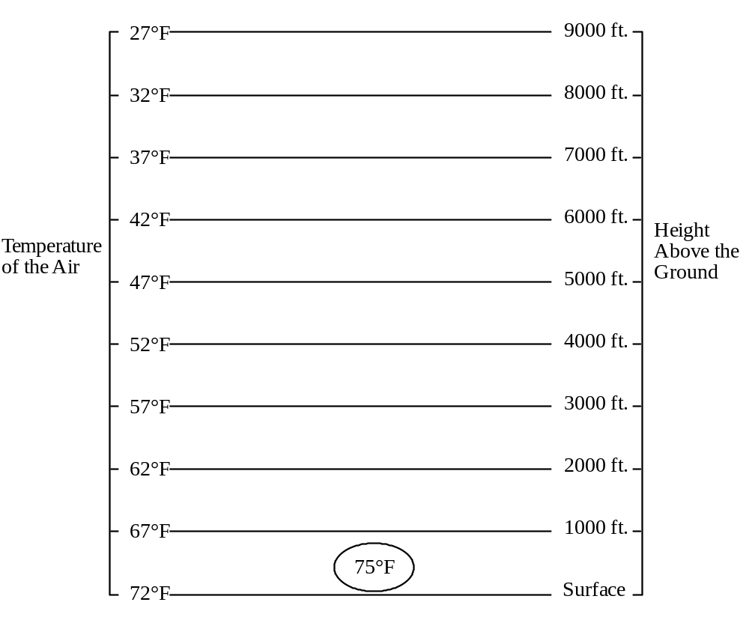
1. How many units of water vapor can the air hold?
(Hint: use your sliding humidity scale)
2. The parcel of air has a relative humidity of 59%. How many units of water vapor is the air holding? Show your calculations.

3. What is the dew point temperature of the air parcel? ° F
4. Note that the air parcel is slightly warmer (for some reason) than the air immediately surrounding it. The air parcel rises. Why?

5. As the parcel of air rises, it enters a region of lower temperature. Why?

(Note: This is an important aspect of what happens when air rises; we will come back to it in letter “k” below. Meanwhile, we will look at the issue of pressure.)
6. The higher you go in the atmosphere, the lower the air pressure. Why?

7. Therefore, as the parcel of air rises, it enters a region of lower pressure. As a result, it expands “adiabatically” (without energy being added or taken away). Why?

8. As the parcel of air expands adiabatically, its temperature increases / decreases .

9. This adiabatic expansion causes a change in temperature (of the air inside the parcel, not of the surrounding air) of 5.5°F for every 1000 ft. rise in altitude. The parcel rises to 2000 ft. above the ground.
a. What is the new temperature of the air parcel?

b. What is the new relative humidity of the air parcel? (Remember: the amount of water vapor in the parcel is still the same as it was n question #2.)

10. In general, as the air parcel rises, its relative humidity increases / decreases . Why?

11. Will the air parcel continue rising? Why or why not? (Hint: Think about the temperature and density of the air parcel in relation to the temperature and density of the surrounding air.)

12. Under what conditions, in general, would an air parcel…
• rise?
• stay where it is?
• sink down?

13. Clouds are made of tiny droplets of liquid water or solid ice. At what temperature will a cloud begin to form? Why?

14. How high above the ground will this air parcel have to rise in order to form a cloud? Why?

15. Will this parcel of air rise that high on its own, due to its natural buoyancy, or will it have to be forced to rise by a weather front, conditions on the windward side of a mountain range or convergence of air? Explain the reasoning behind your answer.

16. What would happen if there were no specks of dust or smoke particles or ice crystals in the air?

17. Extra Thought Question: What if the initial relative humidity had been 20%, would the air parcel rise on its own, due to its natural buoyancy, high enough to form a cloud? Why or why not?
Lab Activity #6: Making a Cloud in a Bottle (Again)

Activity: Make another cloud in a bottle, using the same procedure you used in Activity #1.

Question: Explain why a cloud formed inside the bottle and why it eventually disappeared. In your explanation, USE AND CONNECT ALL of the concepts listed below that apply (not all do).
a. changes in the relative humidity of the air f. changes in the air pressure
b. changes in the amount of water vapor in the air g. expansion or compression of the air
c. changes in the water vapor capacity of the air h. vertical movements of the air
d. evaporation or condensation of water i. availability of surfaces on which
e. changes in the air temperature the water could condense

Lab Activity #7: Making a Cloud in a Beaker (Optional)
Materials: 2 large beakers
2 small metal bowls
crushed ice
water
hot plate
insulating gloves
matches

Activity: Use the materials listed to make a cloud. Clearly and fully explain why the cloud formed.

Instructions for Assembling Sliding Humidity Scale
1. Cut along all lines labeled “cut along this line.” You should have four pieces that look like this:
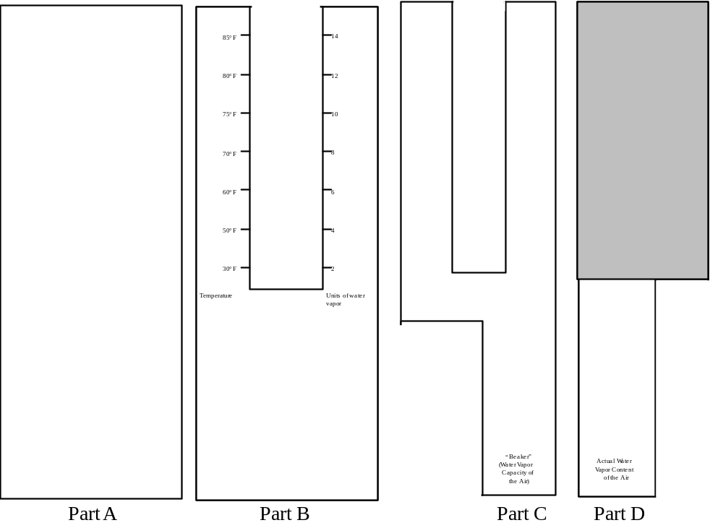
2. Place Part B on top of Part A. Staple the two parts together as shown below, placing the staples as close to the edge as possible.
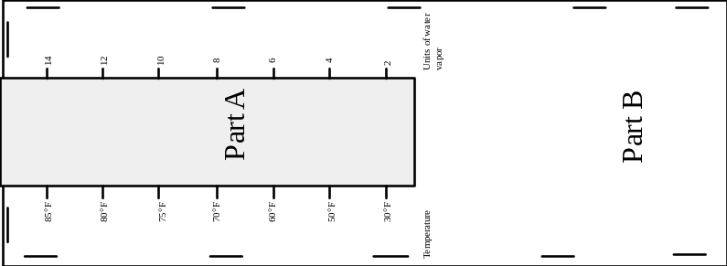
2. Place Part C on top of part D and slide both into the envelope made by Parts A and B. The sliding humidity scale should look like this:
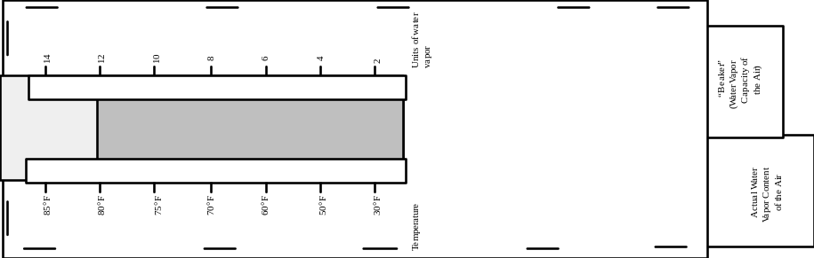

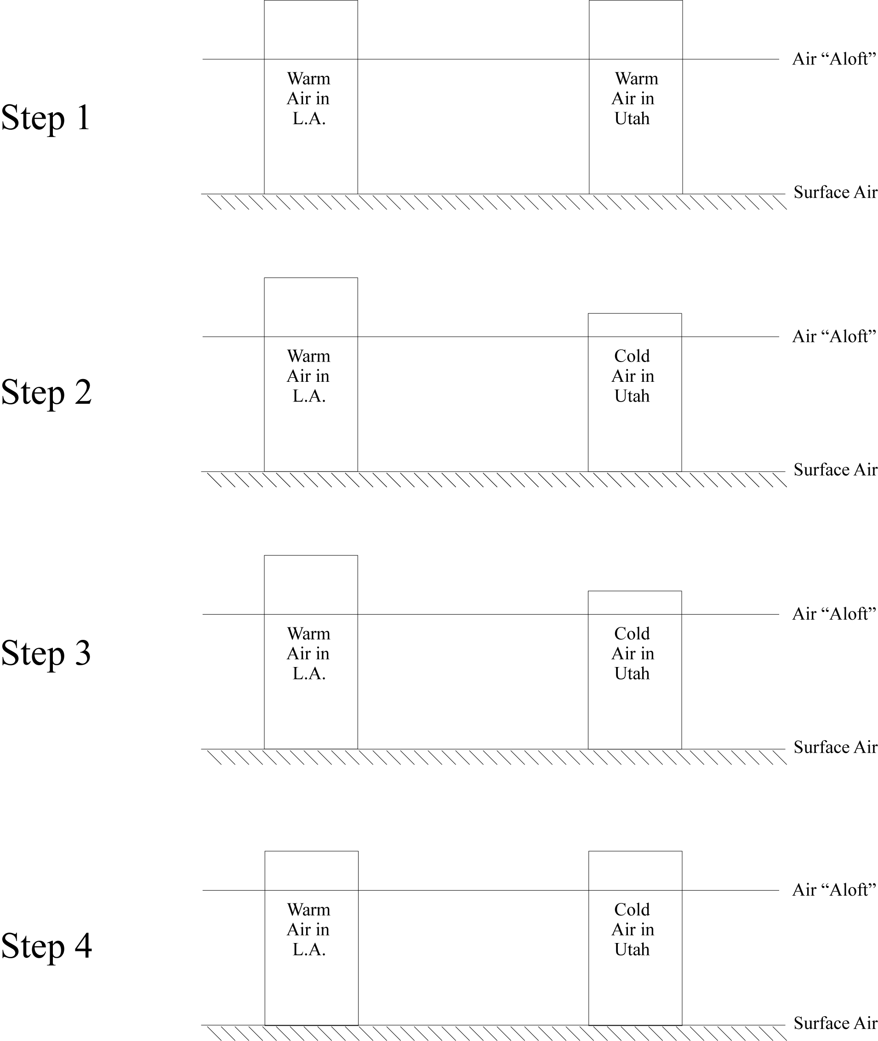
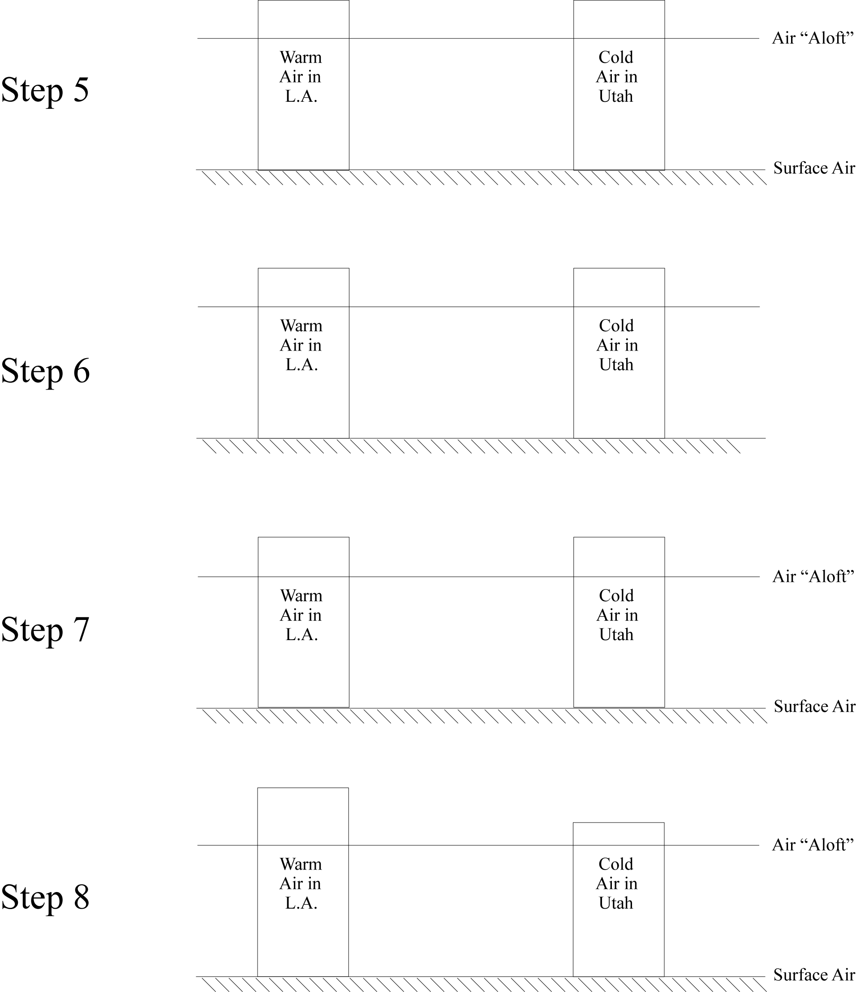
Some Comments on the Real Exam
• This exam covers all material related to meteorology. Specifically, this exam covers all of Part D of your course packet.
• Be sure to bring the following items to the exam: Sliding Humidity Scale
Calculator

Part 1: Modeling a Temperature Inversion in a Valley
Introduction: In this activity, you will model the movement of air in a valley during a calm clear long night (the ideal conditions for forming a temperature inversion); under these conditions, the ground cools a great deal and quite rapidly, cooling the air near the ground. In this activity, you will use water to model the air. You will use a bowl to model the valley; the bottom of the bowl represents the valley floor; the sides of the bowl represent the mountain slopes surrounding the valley.

Materials: Large clear Pyrex bowl
Lukewarm water
Large piece of white paper
Red and blue food coloring
2 eye droppers
crushed ice

Activity: 1. Fill the glass bowl with warm water and place it on the white paper.
2. To make it easier to see the movement of the water during the activity, add a dropper full of red food coloring. Stir gently and let the bowl rest until the food coloring is thoroughly mixed and the water stops moving. The water and bowl now represent the air on a warm sunny day.
3. To model the cooling of the air during the night, have each member of the lab group hold some crushed ice inside the bowl at the surface of the water. Place a drop of blue food coloring on each clump of ice as close to the edge of the bowl as possible (The idea is to have the food coloring trace the cold water that is melting off of the ice.). The melt water from the ice represents air that is cooled by the rapidly-cooling ground.
4. Hold the ice against the side of the bowl until it is almost completely melted. Add blue food coloring as needed, so that you can continue to trace the water currents.
5. Notice where the red water ends up and where the blue water ends up.
Questions: 1. Using concepts you have learned in this class, explain any water currents you see during the experiment.

2. Applying the model you just made to the real world situation of a valley surrounded by mountains, what kinds of air currents (winds) should occur on a cold clear night. Why?

3. At the end of the experiment, where is the water colder, at the bottom of the bowl or at the top of the water surface? How do you know?

4. In a real world situation of a valley surrounded by mountains, temperature inversions--similar to the one you created in the bowl--typically form. Why is this situation called a “temperature inversion?”

5. Complete the graphs below, showing the “temperature profiles” for the air under normal conditions and during a temperature inversion.

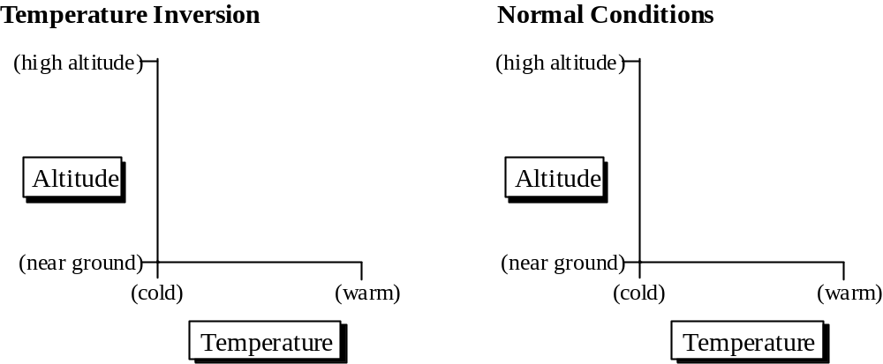
6. Suppose there is a city in the valley. Will the resulting air pollution remain trapped in the valley or will it vent out of the valley? Explain.

7. What would it take to break up the temperature inversion and allow the air to mix vertically? (Hint: There are two ways to do it.)

Part 2: Making a Cloud you can Pour
Introduction: You have made clouds several different ways. We chose to have each of you make a cloud using one of the particularly successful procedures invented by students who took this class in the past.

Materials: 1 gallon glass jug
crushed ice
#8 rubber stopper with hole drilled in it
bicycle pump with needle adapter made for inflating basketballs
matches

Activity: 1. Cover the bottom of the bottle with crushed ice.
2. Add cold tap water until there is about an inch of ice water on the bottom of the bottle.
3. Light a match and toss it in the bottle. IMMEDIATELY cap the bottle.
4. While holding down the cap, pump air into the bottle. Continue pumping until you can't hold down the cap any longer and it “pops” off.
5. Play with the resulting cloud, tipping the bottle back and forth. Turn the bottle sideways and “pour” the cloud out.

Questions: 1. Using the terms relative humidity, temperature, compaction and expansion, explain why the cloud formed.

2. Explain why the cloud “pours” down out of the bottle.

Part 3: Determining If, Why and Where Clouds Will Form in a Particular Situation
1. The graph below shows a parcel of air with a temperature of 85°, located at the surface of the Earth; this graph also shows the temperature of the air at various heights above the ground.
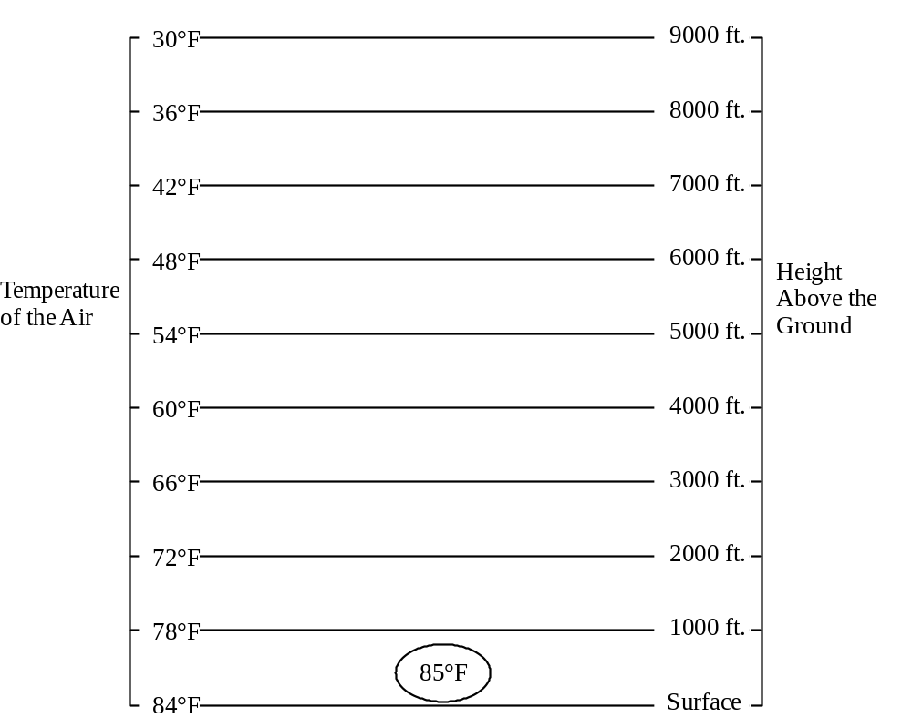
a. The parcel of air has a relative humidity of 50%. What is its dew point temperature?
(Hint: Use your sliding humidity scale.)

b. As this parcel of air rises, it expands and thus cools adiabatically. This cooling results in a 5.5°F temperature drop for every 1000 ft. rise in elevation. The parcel rises to 2000 ft.
i. What is the new temperature of the air parcel?

ii. What is the new relative humidity of the air parcel? (The water vapor content of the parcel has not changed.)

c. Will the air parcel continue rising? Why or why not?

d. To what elevation will this air parcel have to rise in order to form a cloud? Why?

e. Will this parcel of air rise that high on its own, due to its natural buoyancy, or will it have to be forced to rise by a weather front, conditions on the windward side of a mountain range or convergence of air? Explain the reasoning behind your answer.

Part 4: Additional Essay Questions
1. Explain why the prevailing winds in Hawaii are out of the east. Draw diagrams to illustrate your answer.
2. Explain why afternoon thunderstorms are common in Florida but morning thunderstorms are rare.

Part 5: Multiple-Choice Questions
1. The Earth's greatest deserts are located near 30° north and south latitude. This is probably because air is and surface air pressure is at those latitudes.
a. sinking; high
b. rising; high
c. sinking; low
d. rising; low
e. moving eastward; highly variable
2. In the experiment illustrated on the right, mercury has been placed in the beaker inside the Bell jar. A thin glass tube has been filled with mercury and then placed in the beaker of mercury as shown.
If you pump the air out of the Bell jar, the level of the mercury in the glass tube will because the pressure on the mercury in the beaker will .
a. rise; increase.
b. rise; decrease.
c. fall; increase.
d. fall; decrease.
e. stay the same; stay the same.

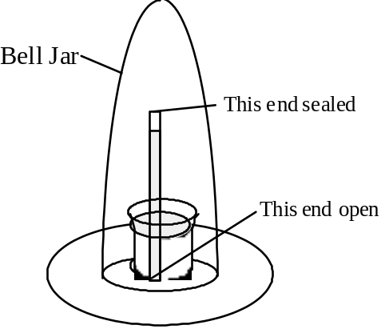

3. Between 0° and 30° north latitude, surface prevailing winds are from the because air that is trying to flow is deflected to the due to the Coriolis effect.

Note: Arrows match written directions (i.e. the visually-oriented can answer this question by choosing the correct arrow).
4. You can lower the relative humidity of air by the amount of water vapor in the air or by the temperature of the air.
a. increasing; decreasing.
b. decreasing; increasing.
c. increasing; increasing.
d. decreasing; decreasing.
e. increasing; you can't affect relative humidity by changing the temperature.
5. Which of the following conditions can cause clouds to form?
a. expanding air.
b. high humidity.
c. a lot of dust.
d. a drop in air temperature.
e. all of the above.
6. When air descends (without exchanging any heat with the surrounding air), the pressure on the air and the temperature of the air .
a. increases; decreases.
b. decreases; increases.
c. increases; increases.
d. decreases; decreases.
e. increases; doesn't change.
7. Does convection occur in the atmosphere? Why or why not?
a. No; because air expands when it rises. As a result, it cools and stops rising, halting the convection process.
b. No; because the atmosphere is heated from above and convection occurs only if a fluid is heated from below.
c. Yes; because, unlike solids (such as the Earth's mantle) or liquids (such as water), gases (such as the atmosphere) can convect even if they are heated from above.
d. Yes; because the ground absorbs the sun's rays and heats up. The warm ground then heats the air from below, causing convection.
e. Yes, but it is rare and requires special circumstances such as a volcanic eruption or a man-made heater inside a room.
8. A sea breeze (when the wind blows inland from the sea) occurs when the pressure of the air above the water is than the pressure of the air above the land.
a. cool; lower; warm
b. cool; higher; warm
c. warm; lower; cool
d. warm; higher; cool
9. Clouds consist primarily of
a. smoke
b. carbon dioxide
c. ozone
d. H₂O vapor
e. liquid water

Part 1: Modeling a Temperature Inversion in a Valley
Questions: 1. Using concepts you have learned in this class, explain any water currents you see during the experiment.

The blue (cold) water flows down the sides of the bowl and settles on the bottom. This happens because this water is colder and therefore denser and less buoyant than the lukewarm water in the bowl.
2. Applying the model you just made to the real world situation of a valley surrounded by mountains, what kinds of air currents (winds) should occur on a cold clear night. Why?

On a cold clear night, the wind on the sides of the valley should blow downhill toward the valley. This happens because, at night, the ground radiates infrared radiation upward but it doesn't absorb any sunlight so it cools off. Energy then flows from the air near the ground into the ground, cooling the air. As the air cools, it compresses and becomes denser and less buoyant. As a result, it sinks.
3. At the end of the experiment, where is the water colder, at the bottom of the bowl or at the top of the water surface? How do you know?
The water is colder at the bottom of the bowl. You can feel it. Also, the water near the bottom stays blue, indicating that the ice-cold water from the melting ice cubes did not mix with the warmer water above.
4. In a real world situation of a valley surrounded by mountains, temperature inversions--similar to the one you created in the bowl--typically form. Why is this situation called a “temperature inversion?”
This situation is called a temperature inversion because, normally, the temperature of the air in the troposphere decreases with height. But in this case the temperature increases with height.
5. Complete the graphs below, showing the “temperature profiles” for the air under normal conditions and during a temperature inversion.

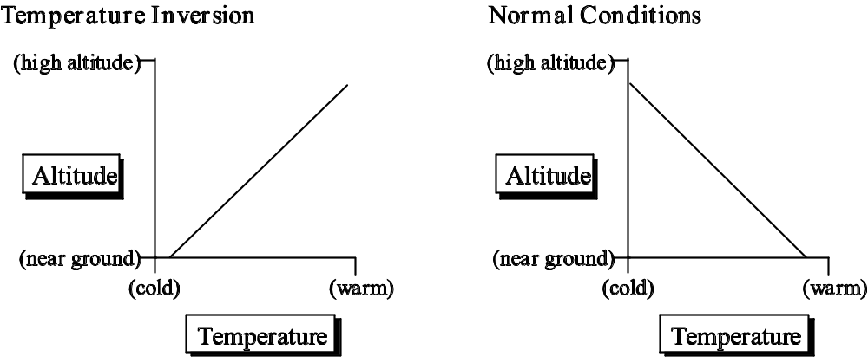
6. Suppose there is a city in the valley. Will the resulting air pollution remain trapped in the valley or will it vent out of the valley? Explain.

During a temperature inversion, air pollution remains trapped in a valley because the increase in temperature with altitude prevents any vertical mixing of the air (i.e. convection cannot take place). The air stays where it is and so does all the smoke, car exhaust and any other kind of air pollution.

7. What would it take to break up the temperature inversion and allow the air to mix vertically? (Hint: there are two ways to do it.)
Method #1: If you heat the bowl from the bottom, you will eventually break up the temperature inversion. Translating to the real world, if the ground can absorb enough energy from the sun to heat up the ground so that it is warmer than the air at high altitudes, then the ground can heat up the air above it, convection can take place to distribute this heat and the temperature inversion will be eliminated.
Method #2: If you would stir the water in the bowl, it would mix vertically. Translating to the real world, if a strong wind would blow in the valley, it could force the air to mix within the valley, thereby eliminating the temperature inversion.

Part 2: Making a Cloud you can Pour

Questions: 1. Using the terms relative humidity, temperature, compaction and expansion, explain why the cloud formed.

When you pump air into the bottle, the air inside the bottle compresses. As a result its temperature increases, causing the relative humidity of the air to decrease because the capacity of the air to hold water increases. Since there is plenty of water inside the bottle, water quickly evaporates until the relative humidity approaches 100%.
When the cap pops off of the bottle, the air inside the bottle suddenly expands as much of it exits the bottle. Because the air expands, its temperature decreases, causing the relative humidity of the air to increase because the capacity of the air to hold water decreases. The relative humidity increases beyond 100% and, because there are plenty of smoke particles for the water to condense on, water condenses in tiny droplets throughout the air inside the bottle, forming a cloud.

2. Explain why the cloud “pours” down out of the bottle.

The cloud pours out of the bottle because it is colder (and therefore denser and less buoyant) than the air in the room. The cloud is cold because it is in contact with crushed ice.

Part 3: Determining If, Why and Where Clouds Will Form in a Particular Situation
1. a. The parcel of air has a relative humidity of 50%. What is its dew point temperature?
(Hint: Use your sliding humidity scale.)
At 85° F, the air can hold 14 units of water vapor. So, if the relative humidity is 50%, the air must actually be holding 7 units of water vapor. According to the sliding humidity scale, air holding 7 units of water vapor is 100% saturated at a temperature of 65° F.

b. As this parcel of air rises, it expands and thus cools adiabatically. This cooling results in a 5.5°F temperature drop for every 1000 ft. rise in elevation. The parcel rises to 2000 ft.
i. What is the new temperature of the air parcel?
The parcel rises 2000 ft. Therefore, its temperature must drop 11°F as it rises.
The new temperature is 74°F (85°F -11°F = 74°F)

ii. What is the new relative humidity of the air parcel? (Hint: use your sliding humidity scale)
The air is still holding 7 units of water vapor.
At a temperature of 74°F, the air can hold about 9.5 units of water vapor.
Thus the relative humidity is 74% (7 units / 9.5 units x 100% = 74%).
c. Will the air parcel continue rising? Why or why not?
Yes, the air parcel will continue rising. At 2000 ft. above the ground, the air in the parcel has a temperature of 74°F. According to the graph on the previous page, the ambient air temperature at 2000 ft. is 72°F. Therefore, the air in the air parcel is still warmer than the surrounding air, so it will continue to rise.

d. To what elevation will this air parcel have to rise in order to form a cloud? Why?
The temperature of the air parcel at the ground is 85°F. Since the dew point of this air is 65° (see answer to question a above), a cloud will form when the temperature of the air parcel drops to 65°F. Thus the air temperature must drop 20°F in order to form a cloud.
Since the temperature of the air parcel drops 5.5°F for every 1000 ft. rise in elevation, the air parcel has to rise to about 3640 ft. in order for a cloud to form. Here are the calculations:
1000 ft = X
5.5° F 20°F
X = 1000 ft. x 20°F / 5.5°F = 3640 ft.

e. Will this parcel of air rise that high on its own, due to its natural buoyancy, or will it have to be forced to rise by a weather front, conditions on the windward side of a mountain range or convergence of air? Explain the reasoning behind your answer.
This parcel will rise that high on its own, due to its natural buoyancy.
We already know that at 2000 ft, the air parcel is still warmer than the surrounding air, so it will continue to rise. At 3000 ft, the temperature of the surrounding air will be 66°. The air parcel will cool 16.5°F (to 68.5°F) as it rises to 3000 ft. (5.5°F/1000 ft. x 3000 ft. = 16.5°F). Thus the air parcel will still be warmer than the air surrounding it. In fact, every time we do these calculations, for any elevation below 3640 ft., the air parcel will always be warmer (and therefore less dense and more buoyant) than the surrounding air.
At 3640 ft, the temperature of the surrounding air will be around 62°F. Thus the air parcel will still be warmer than the surrounding air at that elevation. Thus, not only will the air parcel naturally rise to 3640 ft., it will continue rising once it gets there.

Part 4: Additional Essay Questions
1. Explain why the prevailing winds in Hawaii are out of the east. Draw diagrams to illustrate your answer.
North 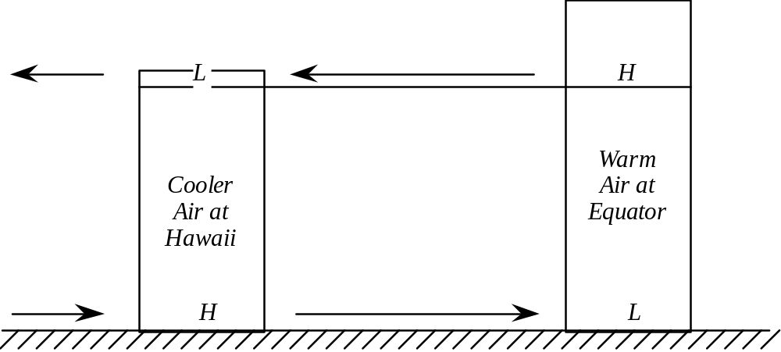 South
Hawaii has a latitude of about 20° N. Thus it is within the region of the easterly trade winds (between 30°N and 30°S). At the equator, the column of air is taller because the air is warmer. Thus at high altitudes (aloft), the air pressure is higher above the equator than it is above Hawaii. Winds aloft therefore try to blow from the equator toward Hawaii (and beyond, even further north where the air pressure aloft is even lower). As a result, air is removed from the top of the column of air at the equator. Thus, at the equator, the surface air pressure is lower than is the surface air pressure in Hawaii, where no air is being removed aloft. As a result, surface air tries to flow from Hawaii toward the equator (i.e out of the north, toward the south). However, the wind is deflected toward the right by the Coriolis effect. So, instead of blowing toward the south, the wind blows toward the southwest (i.e. out of the northeast).
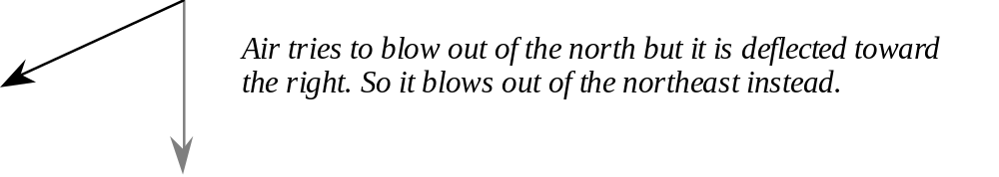
2. Explain why afternoon thunderstorms are common in Florida but morning thunderstorms are rare.
In the afternoon, the land has been soaking up sunlight all day and, because it takes less energy to increase the temperature of the land than it does to increase the temperature of the ocean, the land has become warmer than the ocean. As a result, the air above the land is warmer than is the air above the ocean. Aloft, there is a high pressure over Florida and low pressure over the oceans on either side. Thus winds aloft blow outward away from Florida. As a result, there is thinner than normal air aloft above Florida. Air rises up to fill in the “gap.” Rising air tends to expand, cool and form clouds, especially over Florida where the relative humidity at the ground is already very high.
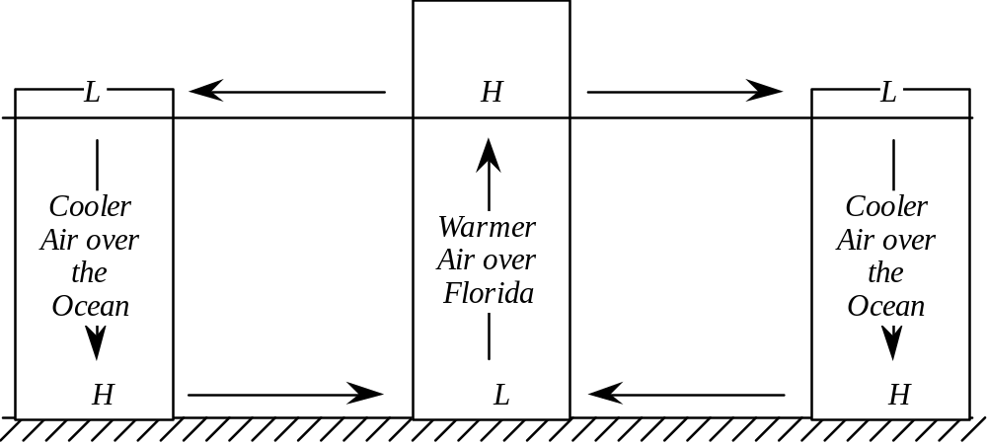
In the morning, the land has been radiating heat into space all night and, because it takes less energy loss to decrease the temperature of the land than it does to decrease the temperature of the ocean, the land is cooler than the ocean. As a result, the air above the land is cooler than is the air above the ocean. Aloft, there is a low pressure over Florida and high pressure over the oceans on either side. Thus winds aloft blow inward toward Florida. As a result, air piles up aloft above Florida. Gravity pulls this air down and air sinks over Florida. Sinking air tends to compress and heat up, clearing the air of any clouds. So, in the morning, the air above Florida tends to be clear.
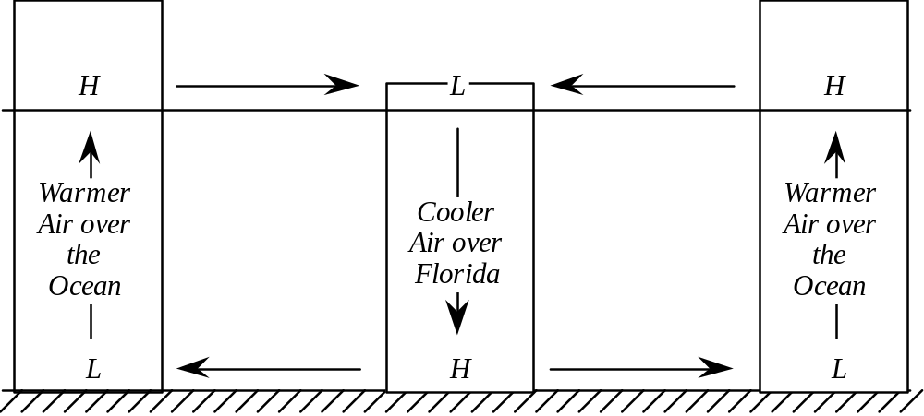

Part 5: Multiple-Choice Questions
1. a
2. d
3. b
4. b
5. e
6. c
7. d
8. b
9. e

Point Value: 20 points
Due date: By Friday of Final’s Week, 11:59 p.m. Submit electronically, using Blackboard Vista. If you compose your submission on word processing software, please “copy and paste” into the box provided. DON’T attach your document. Thanks!
What the “Concluding Comments” Should Consist Of
1. (10 points) On at least one full typed page (double-spaced is fine), describe the most important thing you learned in this class and how you learned it (did you read about it, listen to a lecture, do an activity, talk to a classmate, solve a problem, prepare a presentation, work on a project?). Describe the thought process that lead you from a lack of understanding to a thorough understanding (what went through your mind as you were learning?).
2. (10 points) Write an evaluation, at least one full typed page in length (double-spaced is fine), of the worth of any of the following to your education:
• weekly homework
• course packet (handouts)
• the course Blackboard Vista site
• lecture activities
• clickers
• videotapes
• the textbook
• lab activities
• working in groups
• whiteboard presentations in lab
• class discussions in lab
• the planetarium
• the field trip to Bidwell Park
• the moon project
• teaching children about the phases of the moon
• teaching children about the seasons
• exams
This evaluation is graded credit/no credit (you get 10 points if you write a full page; 0 points if you don't), so tell us what you really think.

The
End

Have a Great Summer!

Nitrogen does, however, have a very important indirect effect on our lives. Plants need nitrogen to make protein. We need to eat protein in order to build and maintain our muscles--we can't live long without it.
Because the water vapor content of the air is so variable, we don't include water vapor when we report the proportions of the various gases in the atmosphere. That is why, in the discussion above, the percentages of nitrogen, oxygen, argon, carbon dioxide and “other” gases add up to 100%. The water vapor is, in a way, “extra.”
“Temperature” is a property of matter. When we measure temperature, we measure the temperature of some object or substance. Empty space cannot have a temperature.
Actually, some of the internal heat energy in the atmosphere comes from Earth's interior. But that amount of energy is so minuscule in comparison to the amount that comes from the sun that it has essentially no effect on the temperature of the atmosphere. The energy from the sun hits the top of the atmosphere at an average rate of 0.5 calories per cm2 per minute. By contrast, heat from Earth's interior reaches the surface at a rate of only about 0.00007 calories per cm2 per minute. This heat flow from Earth's interior adds, at most, 0.1°C to the temperature of the atmosphere (Cole, 1980, p. 120).
For those who want to be perfectly precise, the standard value for atmospheric pressure at sea level is actually 1013.25 mb, which equals 14.4 pounds per square inch (Ahrens, 1998, Essentials of Meteorology, p. 136)
1 kilogram/square centimeter x 150 square cm = 150 kilograms. Similarly, 14.2 pounds/square inch x 23 square inches = 330 pounds.
Calculations: MetricUnitsEnglishUnitsVolume of Glass400milliliters14fluid ouncesWeight of water in glass0.4kilograms0.88poundsDiameter of glass7.136cm2.8inchesArea of mouth of glass40square cm6.2square inchesDownward pressure Exerted by water in glass0.01kg/square cm0.14lb/square in 4 ounces = 0.875 pounds 0.875 pounds/square inch x 23 square inches = 338 pounds. Similarly, 1 kilogram/square centimeter x 150 square cm = 150 kilograms.
In water (as in all liquids), the pressure is always the same in all directions. In rocks (as in all solids), tectonic forces, such as those near plate boundaries, can cause the pressure to be different in different directions. When this happens, the rocks will undergo faulting, folding and other deformation.
We use the phrase “trying to flow” here because, usually, the air does not actually flow directly from a region of high pressure to a region of low pressure. The pressure gradient force pushes the air that way but, as the air flows, the Earth rotates underneath it, causing it to end up somewhere other than where it was heading. We will examine this phenomenon, called the Coriolis effect, more closely soon.
Actually, there must also be enough particles--such as smoke or dust--floating around in the air on which the water vapor can condense. But, 99.9% of the time, there is plenty of “crud“ in the air to allow condensation to occur so we don't have to worry too much about this limitation.
Meteorologists have found it very useful to imagine such a parcel of air when they try to figure out how air behaves because it lets them look at one small portion of the air at a time.
Vertical differences in air pressure do not cause wind. If the pressure gradient force and the force of gravity are out of balance, air may rise or sink but we do not consider such air movement “wind.”
Meteorologists always name winds by the direction from which they come, not the direction they are going. For example, a west wind comes out of the west (and blows toward the east).
Meteorites, jet planes, rockets and weather balloons have no trouble crossing this barrier, but air molecules do.
In water as well as in air, the pressure you experience is proportional to the weight of the water or air above you. In other words, it is proportional to the number of molecules of air or water above you.

